Deployment of WordPress Application Using Docker Compose

1)Type “EC2” in search bar and select the “EC2” option from below.

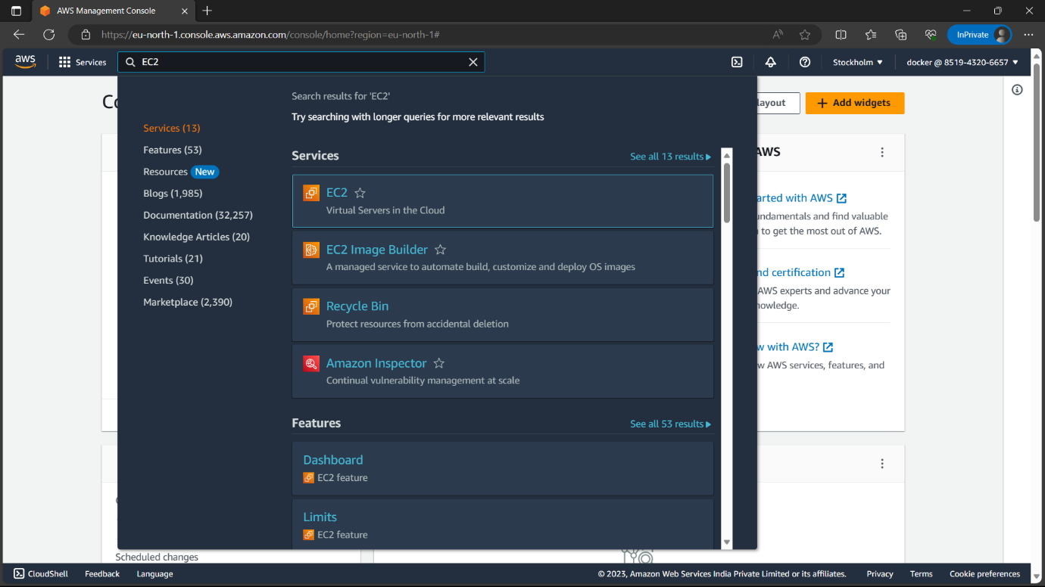

2)Click on “Launch instance” to create an instance.

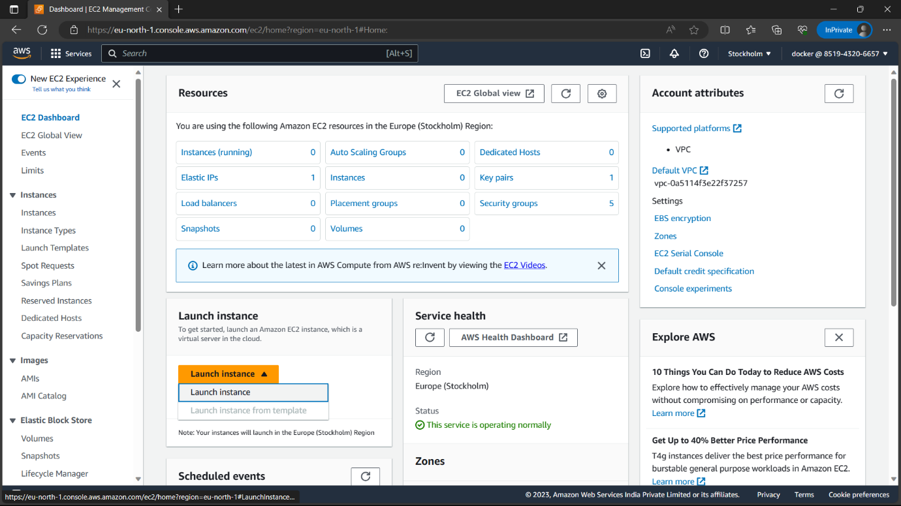

3)Give a name to the instance.

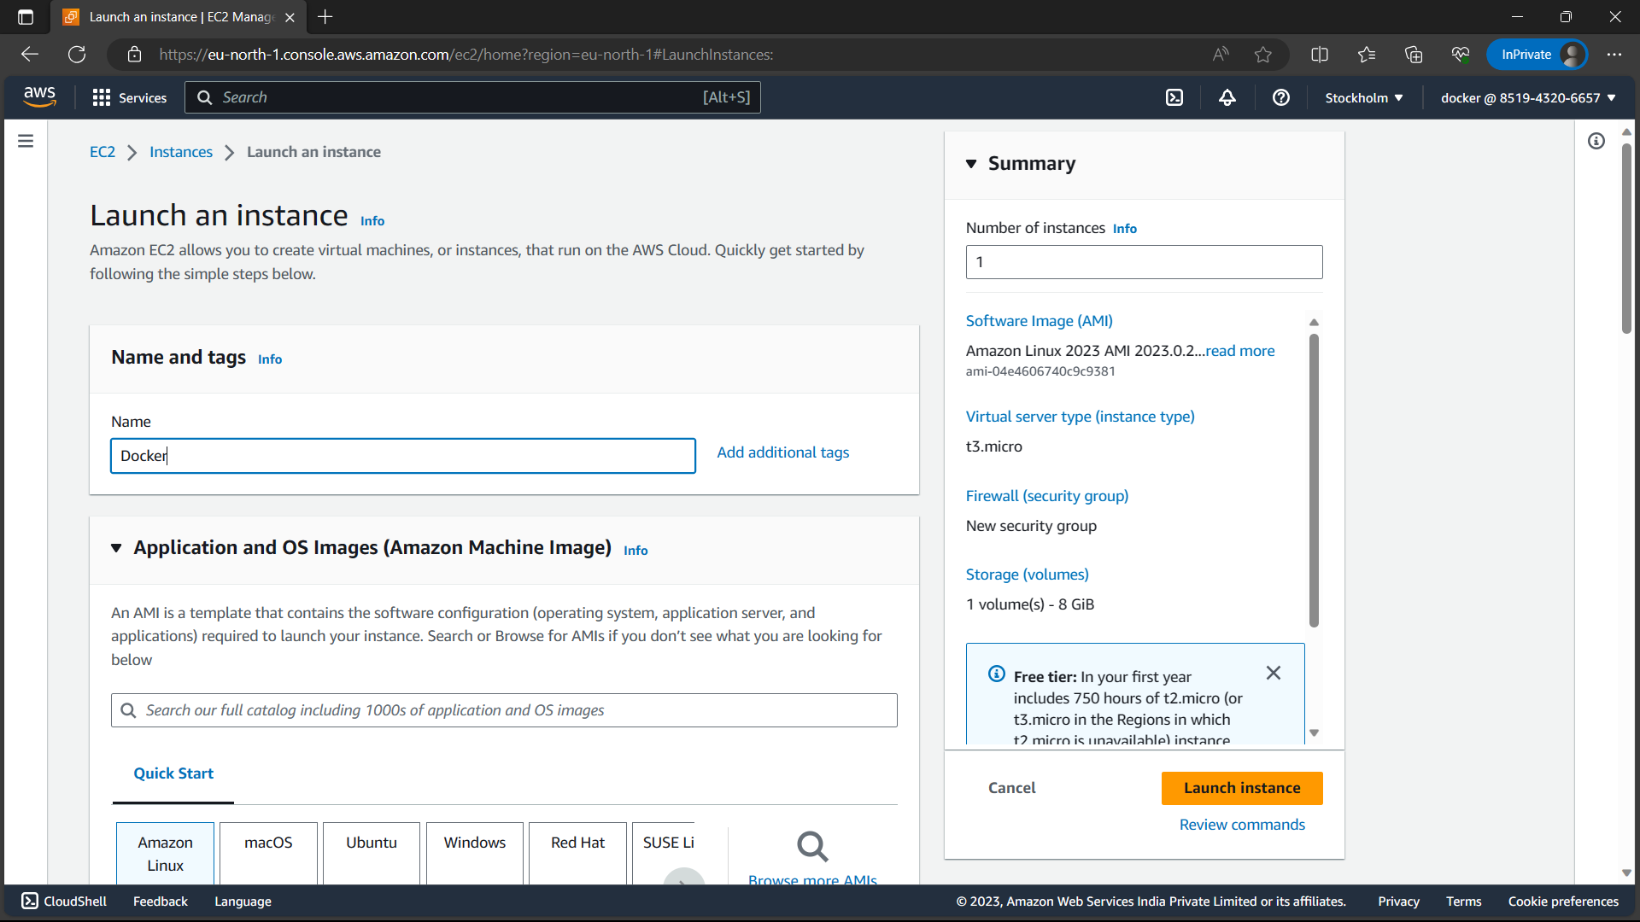

4)Select AMI-“Ubuntu” and let everything be default.

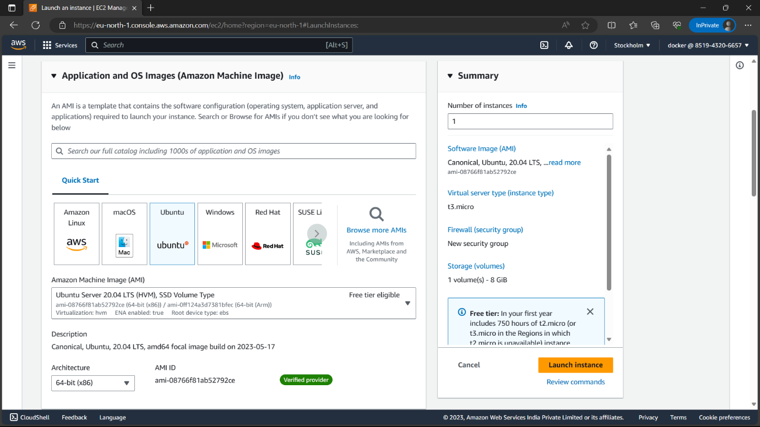

5)Instance type-“t3.micro”,keypair-“select the keypair you have on your local machine”.

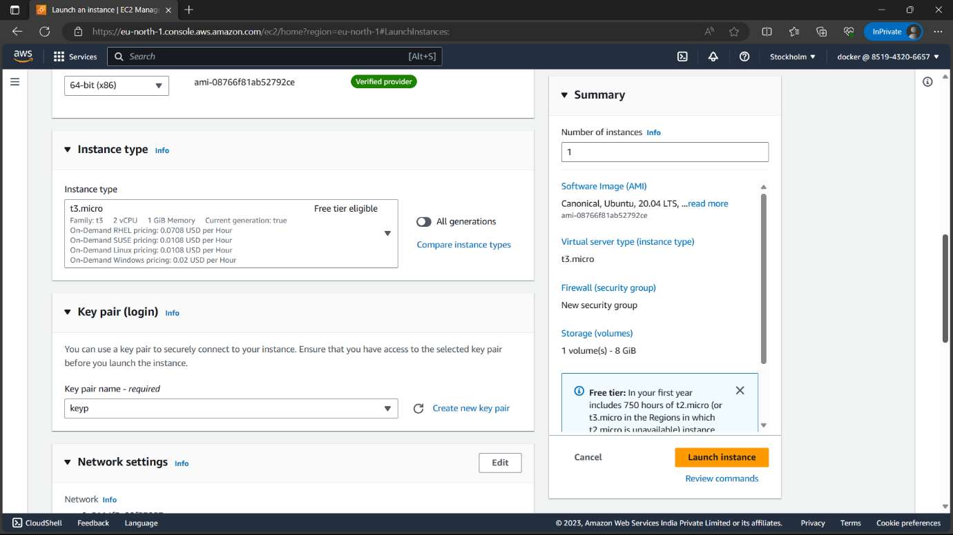

6)Enable “Allow HTTPS traffic form internet” option and review everything and click on “Launch instance”.

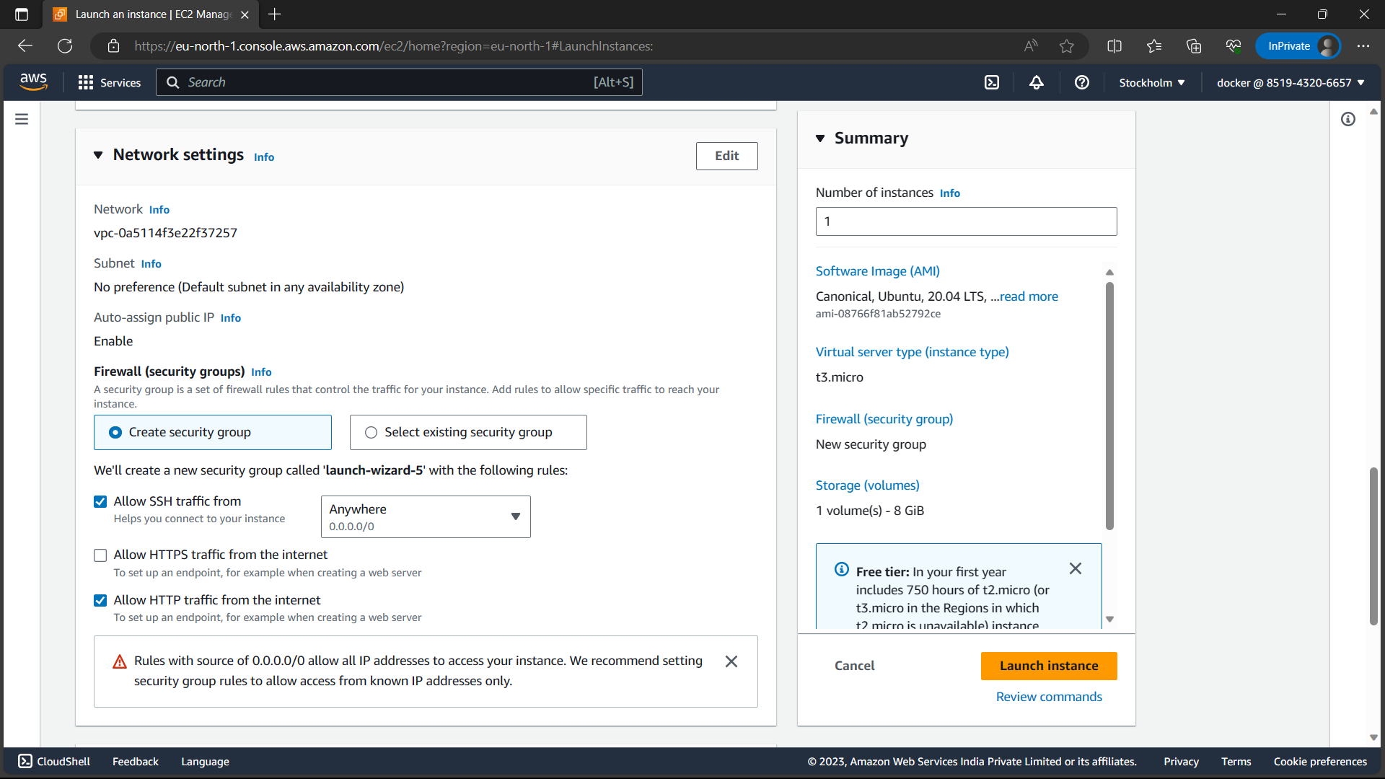

7)Now the instance is created.

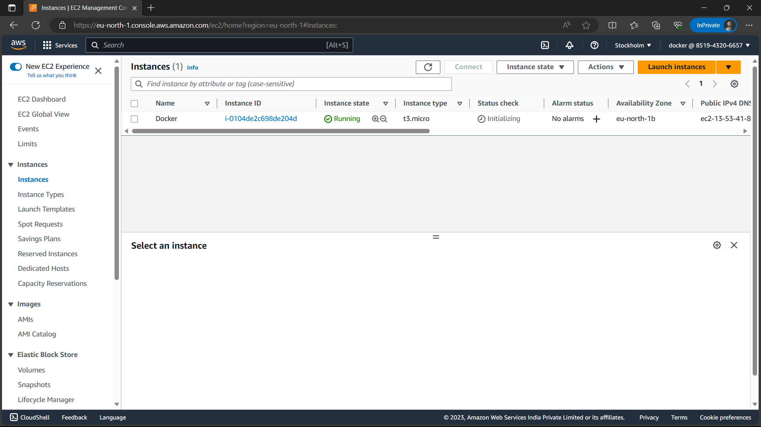

8)Wait till the instance status-: “available”, status check:- “2/2 passed”.

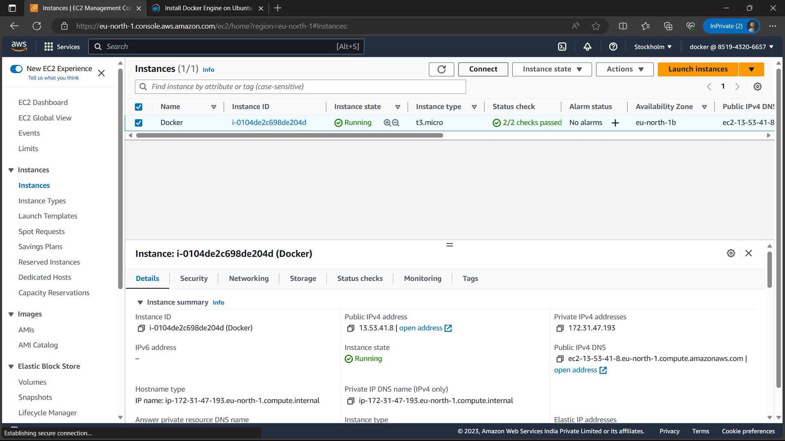

9)Now select the instance and click on “connect” option.



10)Browse to “SSH Client” and copy the command below “Example”.

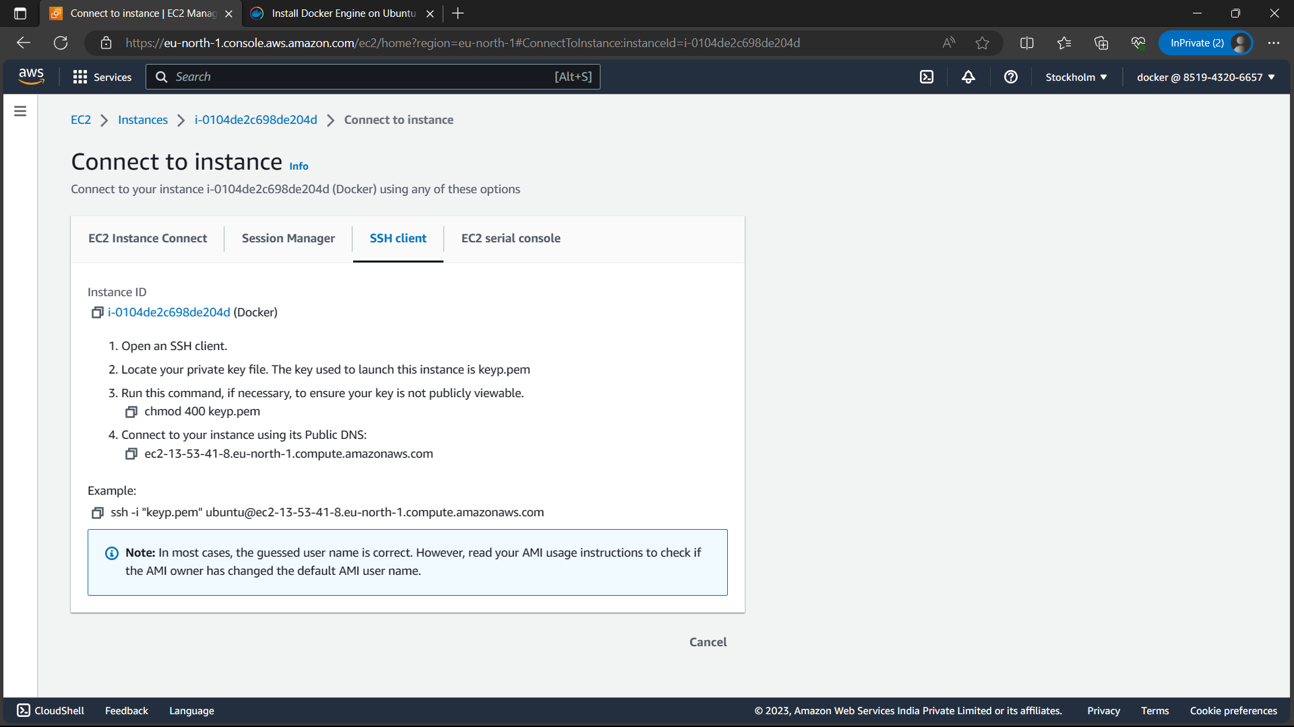

11)Open command prompt in your local machine.

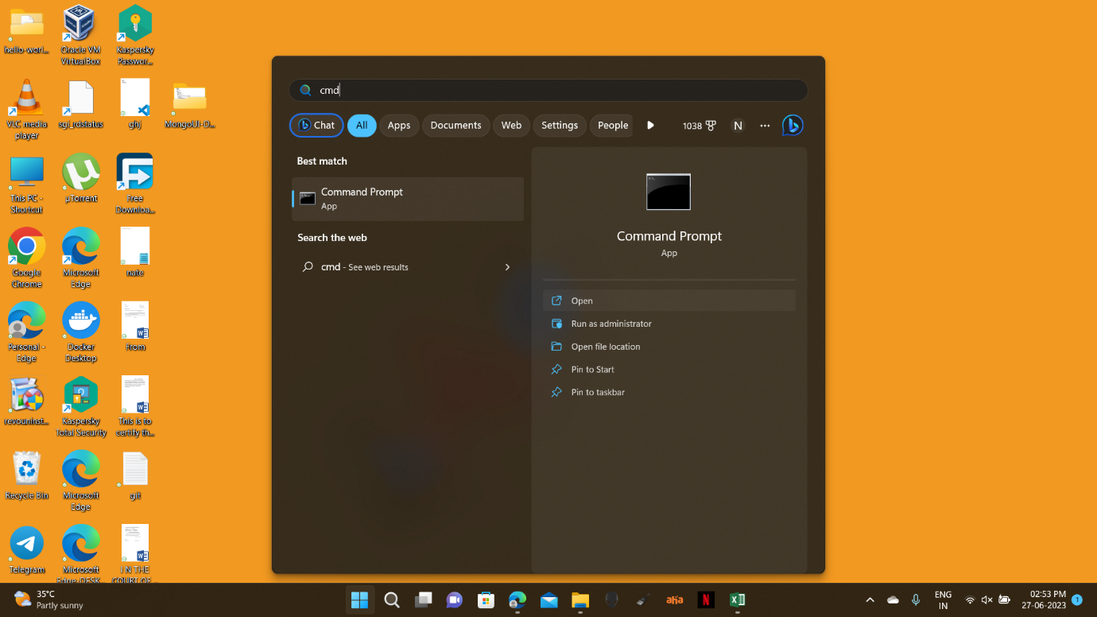

12)”cd downloads” where the key pair is located in your local machine.

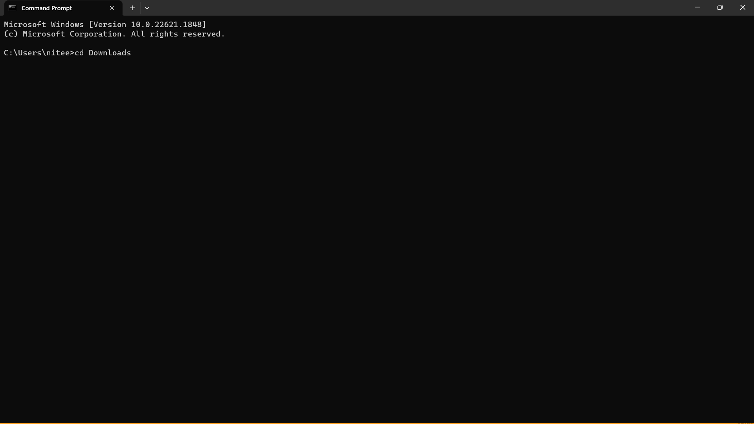

13)Now paste the command below the example and click on “enter” form keyboard. Now command prompt is created to instance.

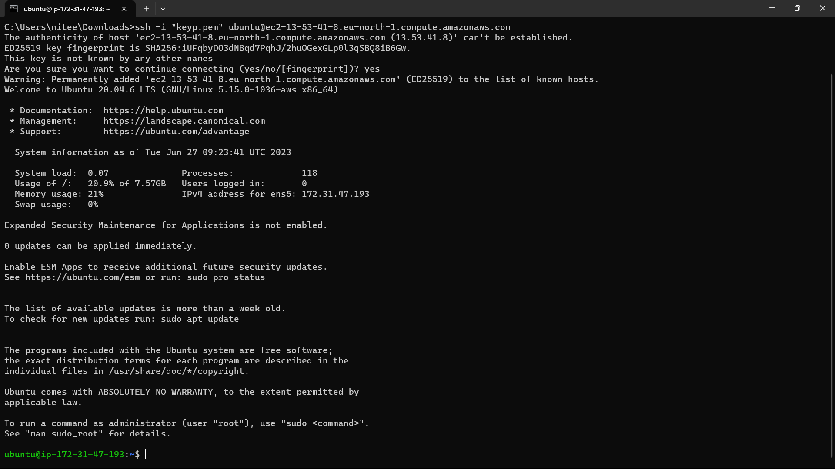

14)Copy the commands from below link and paste it commands prompt for docker, docker compose installation.

Link: <https://docs.docker.com/engine/install/ubuntu/>.

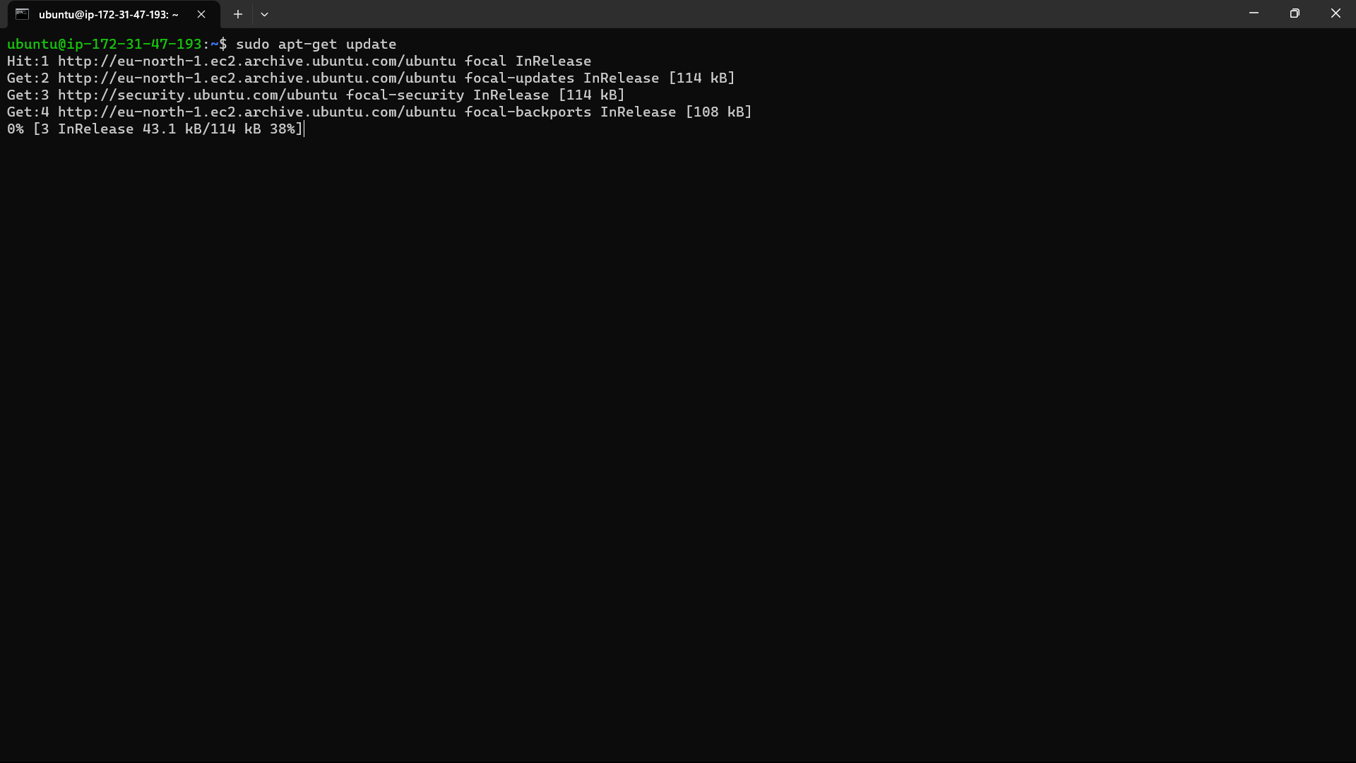

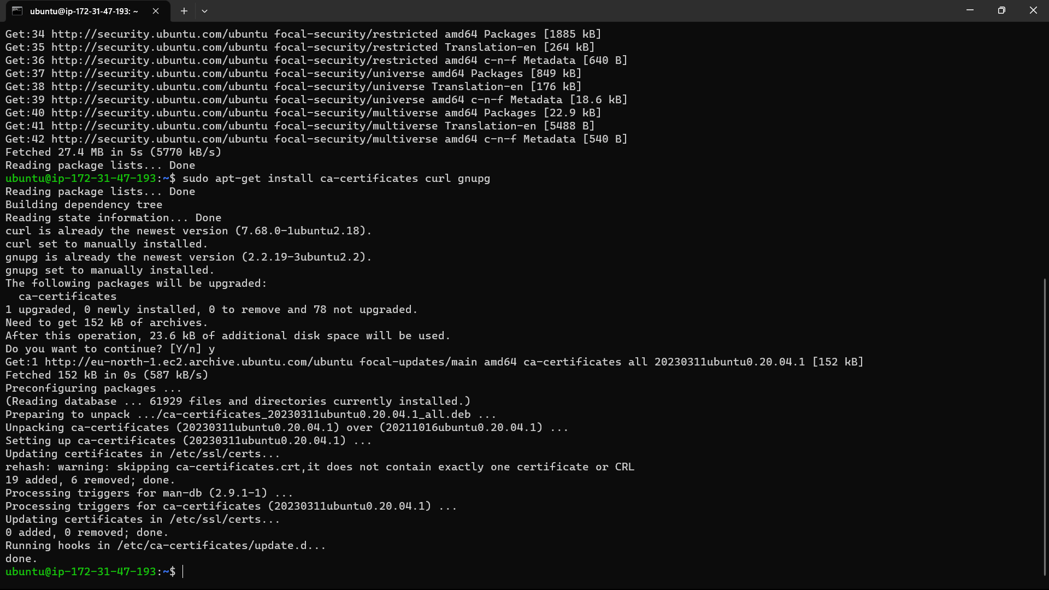

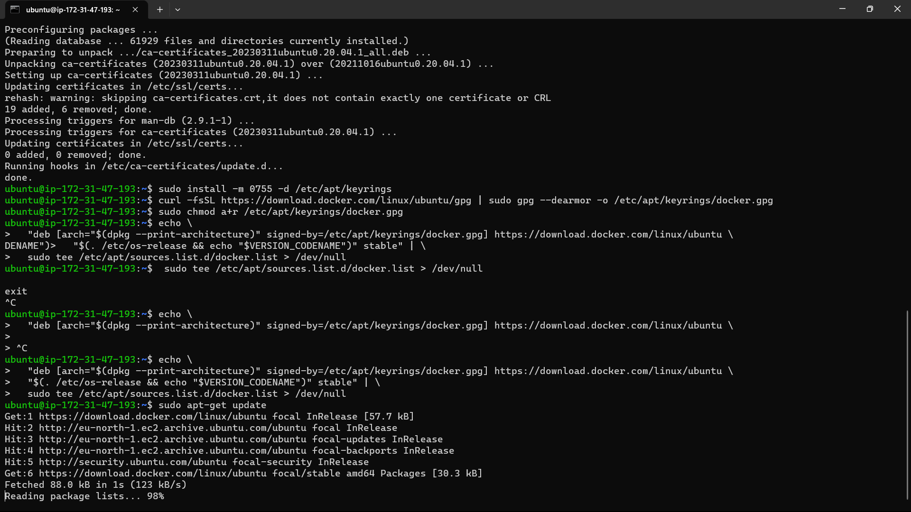

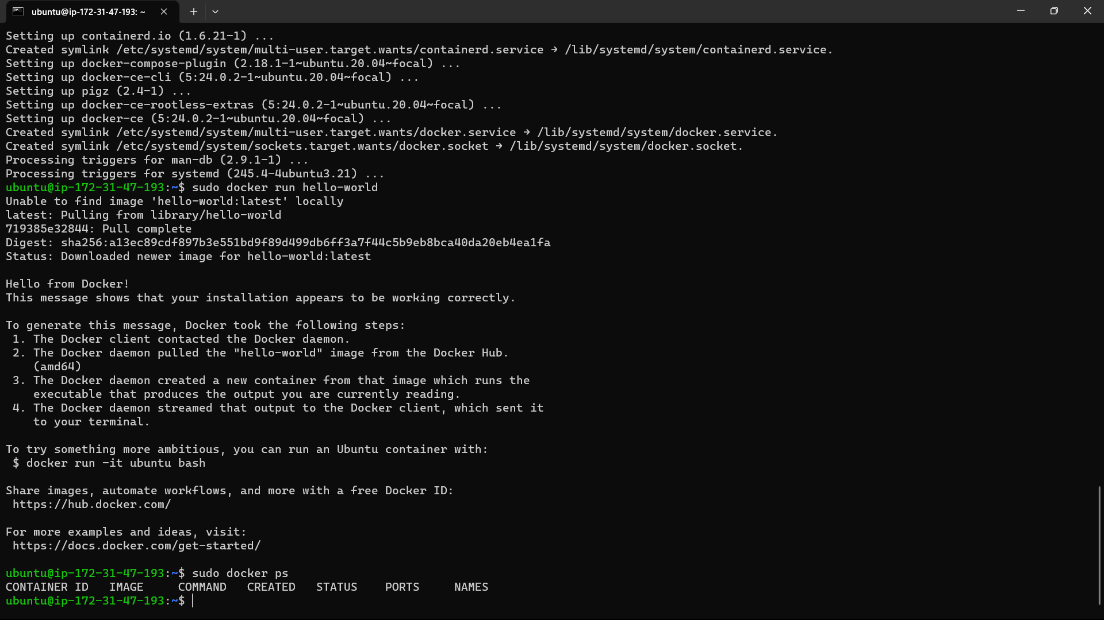

15)Now create a repo a navigate inside the repo by following the commands below:”mkdir jkl”

“cd jkl”.

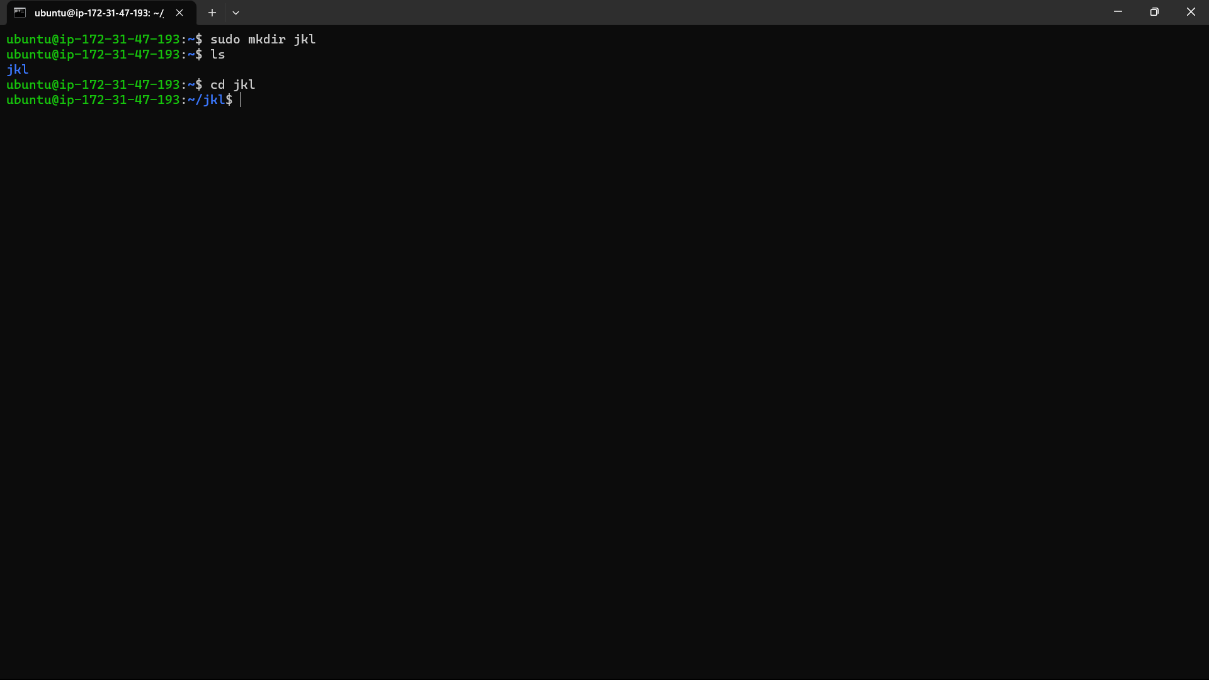

16)Type the command “sudo vi docker-compose.yaml” and copy the code below “Example” of wordpress in the given link and paste it in the yaml file.

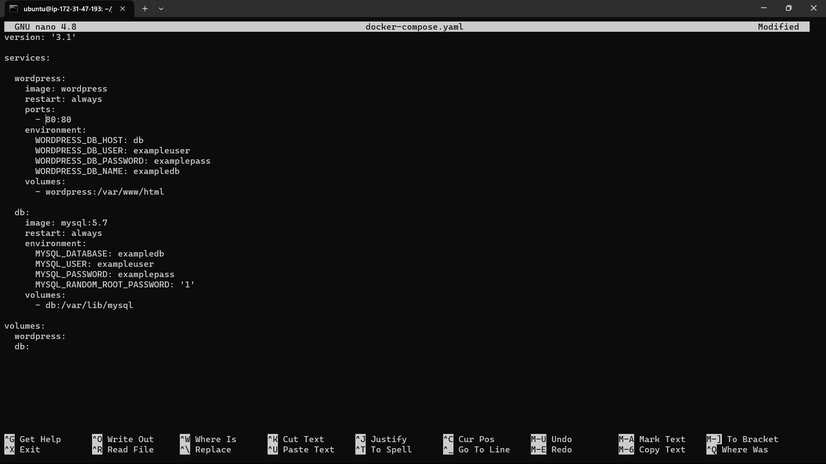

17)Create another two repositories for database and and wordpress using the below commands. “sudo mkdir data” for database and “sudo mkdir wordpress” for wordpress. you can check it using the command “ls”.

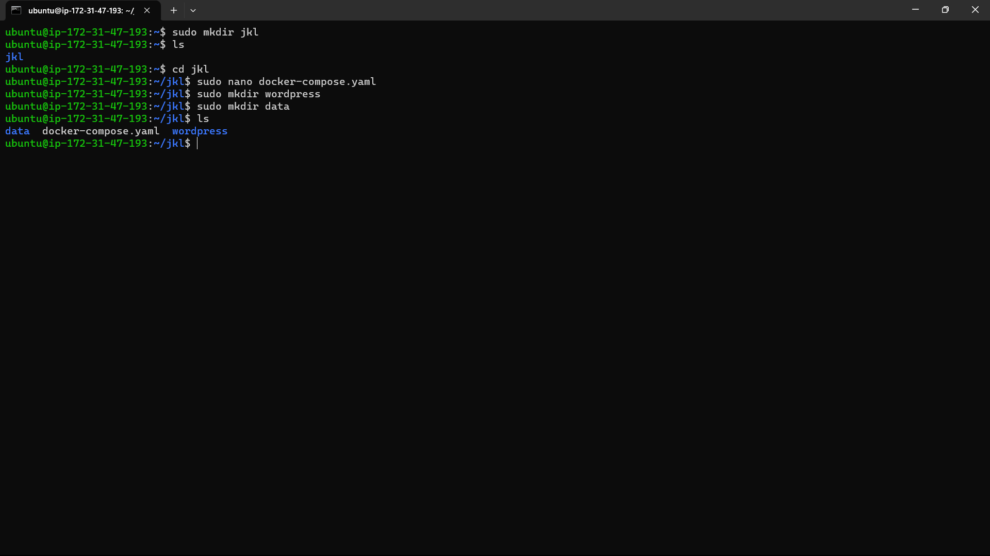

18)Now try docker compose command “sudo apt install docker-compose.yaml” you will get an error.

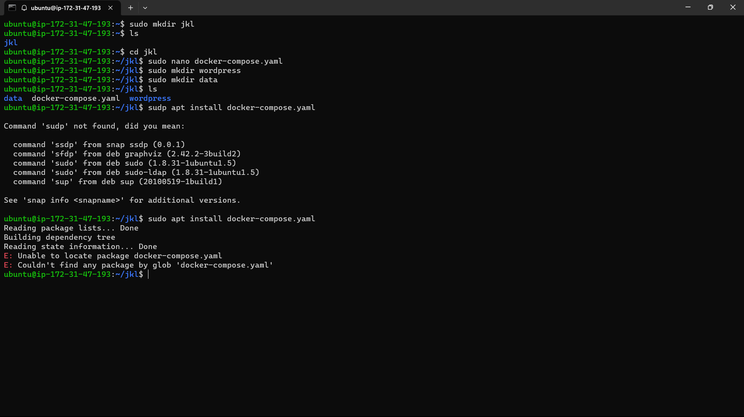

19)Now give the command “sudo docker compose up &” now it run both the containers simultaneously.

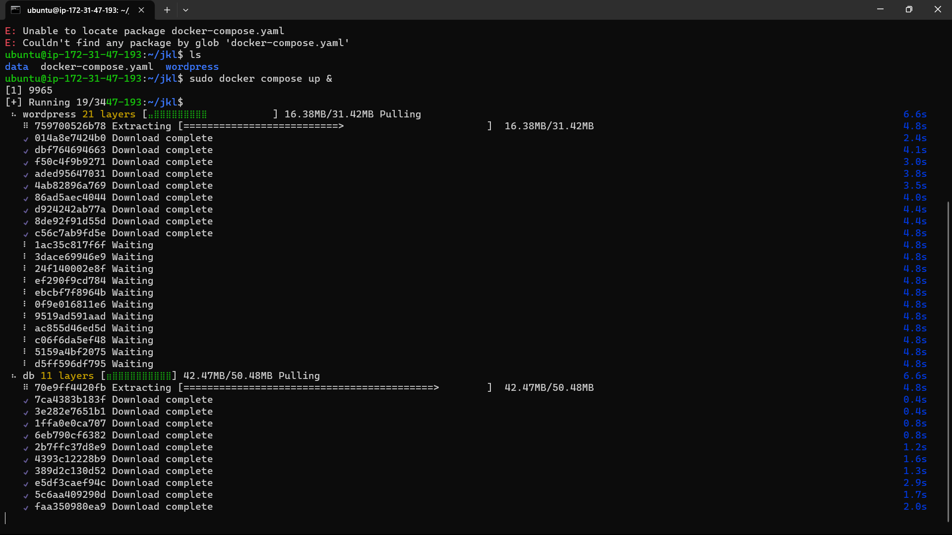

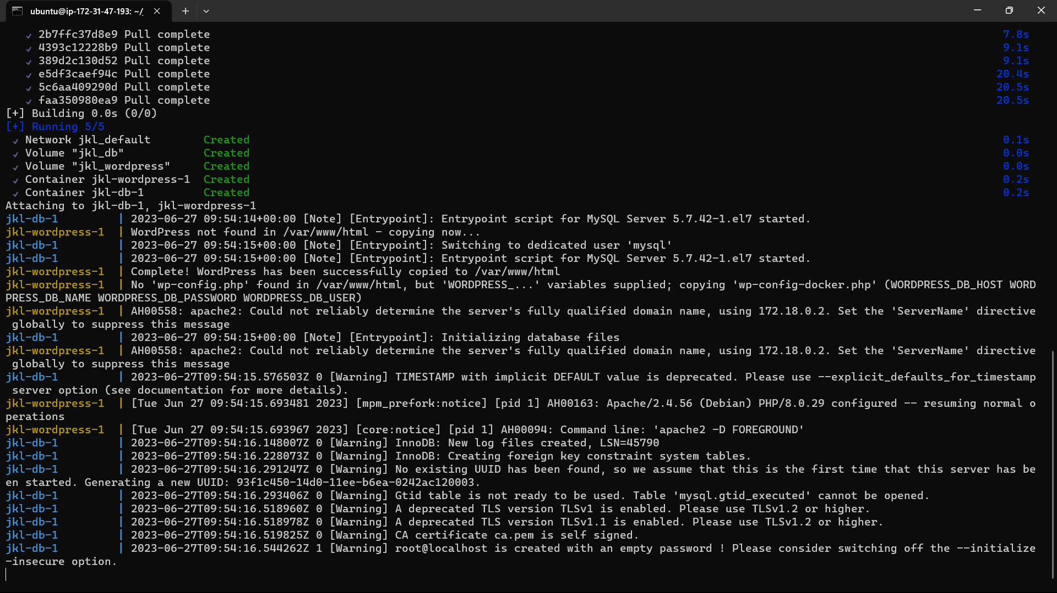

20)Go to instance and copy the ipv4 address of the docker instance and paste it in browser.

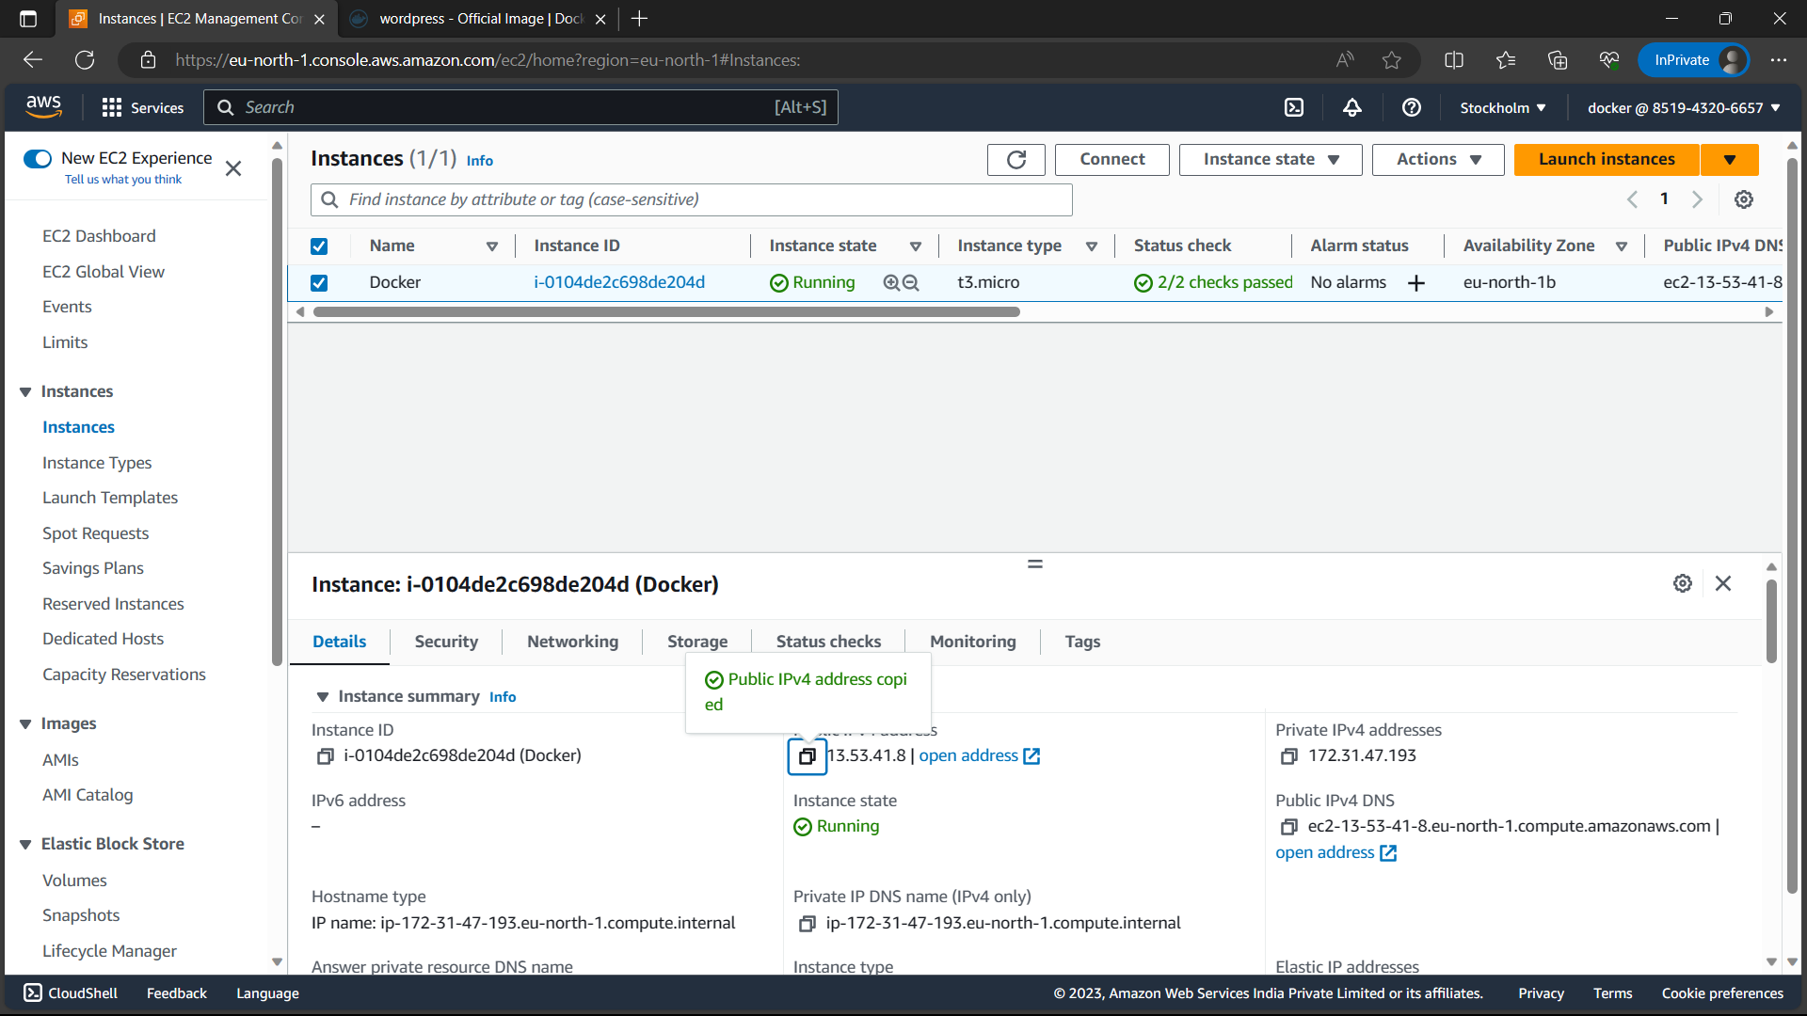

21)We can see wordpress in new tab.

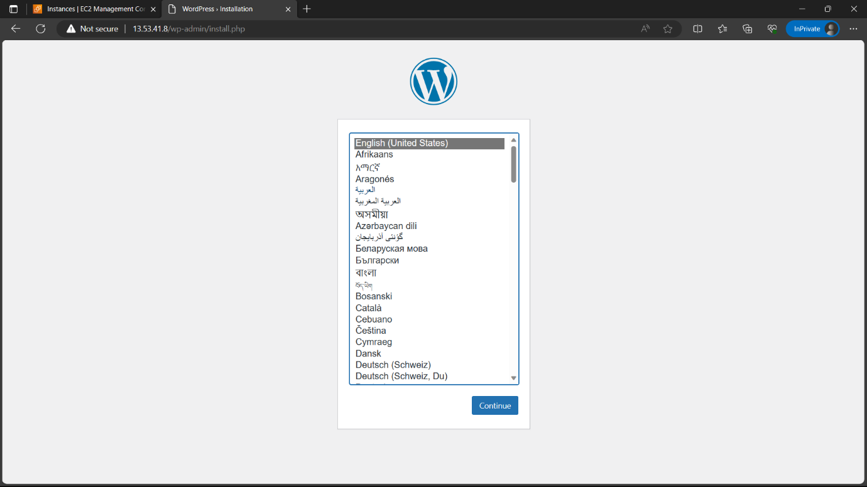

22)Log in to github and click on “create new repository”.

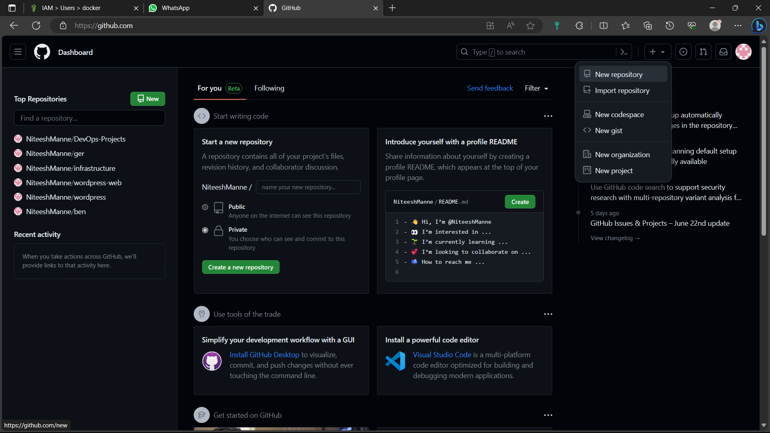

23)Give a name to the repository and click on “create repository”.

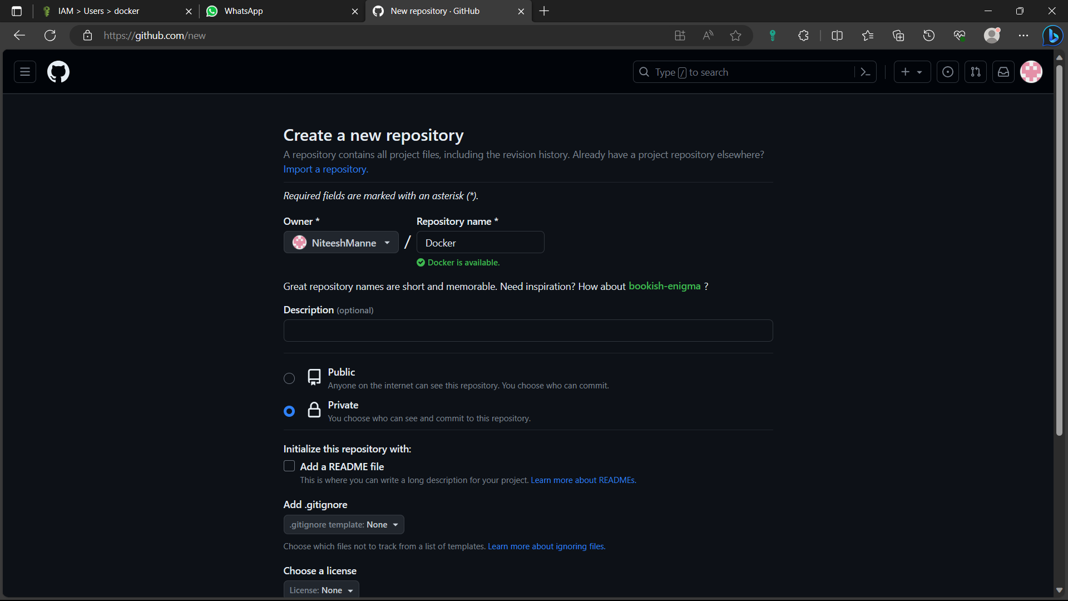

24)Install or update git in the instance.

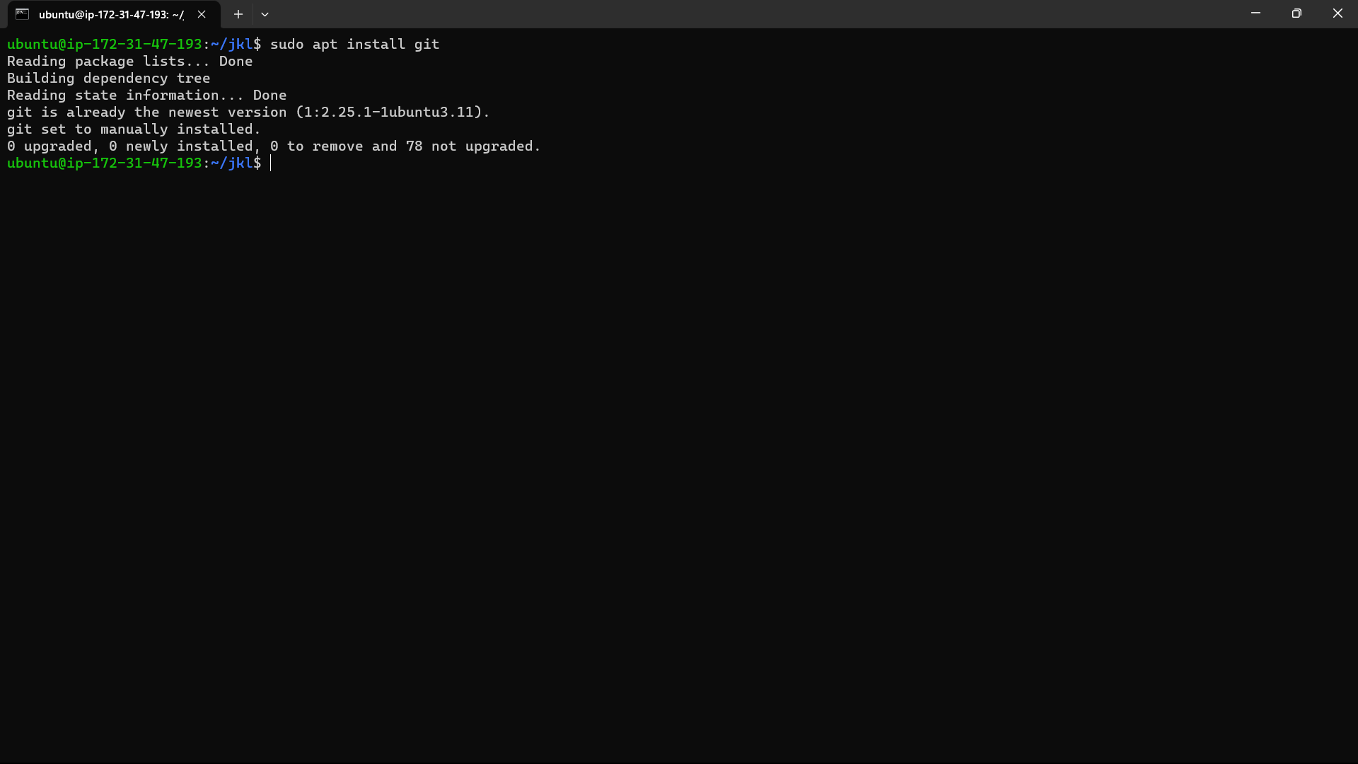

25)Clone the created git repo in instance using the command “git clone GitHub repo URL”. Type username and personal access token of you github account.

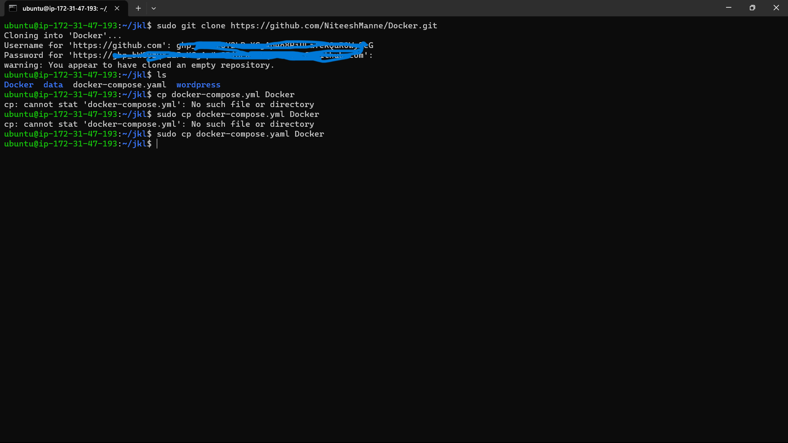

26)”ls”:To see list of file

“sudo cp docker-compose.yaml Docker”: to copy docker compose file to Docker repo.



27)use the below commands to push the file to github from your local machine.

“git add filename”: To track the file with git

“git commit -m “<message>””

“git push -u origin main””: push the file to github.

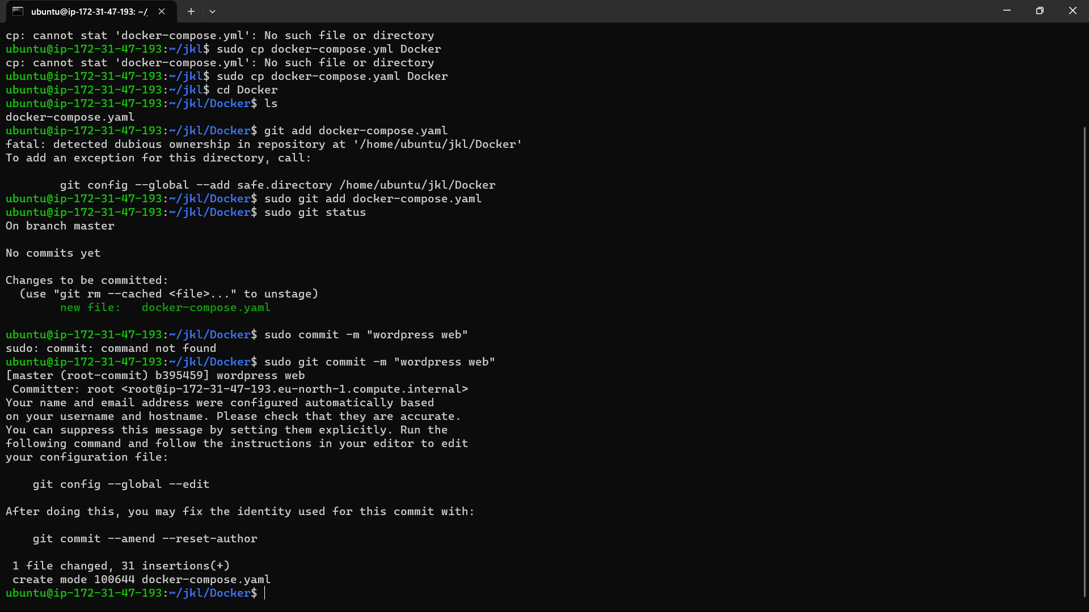

Type the username, password after using git push command in the instance.

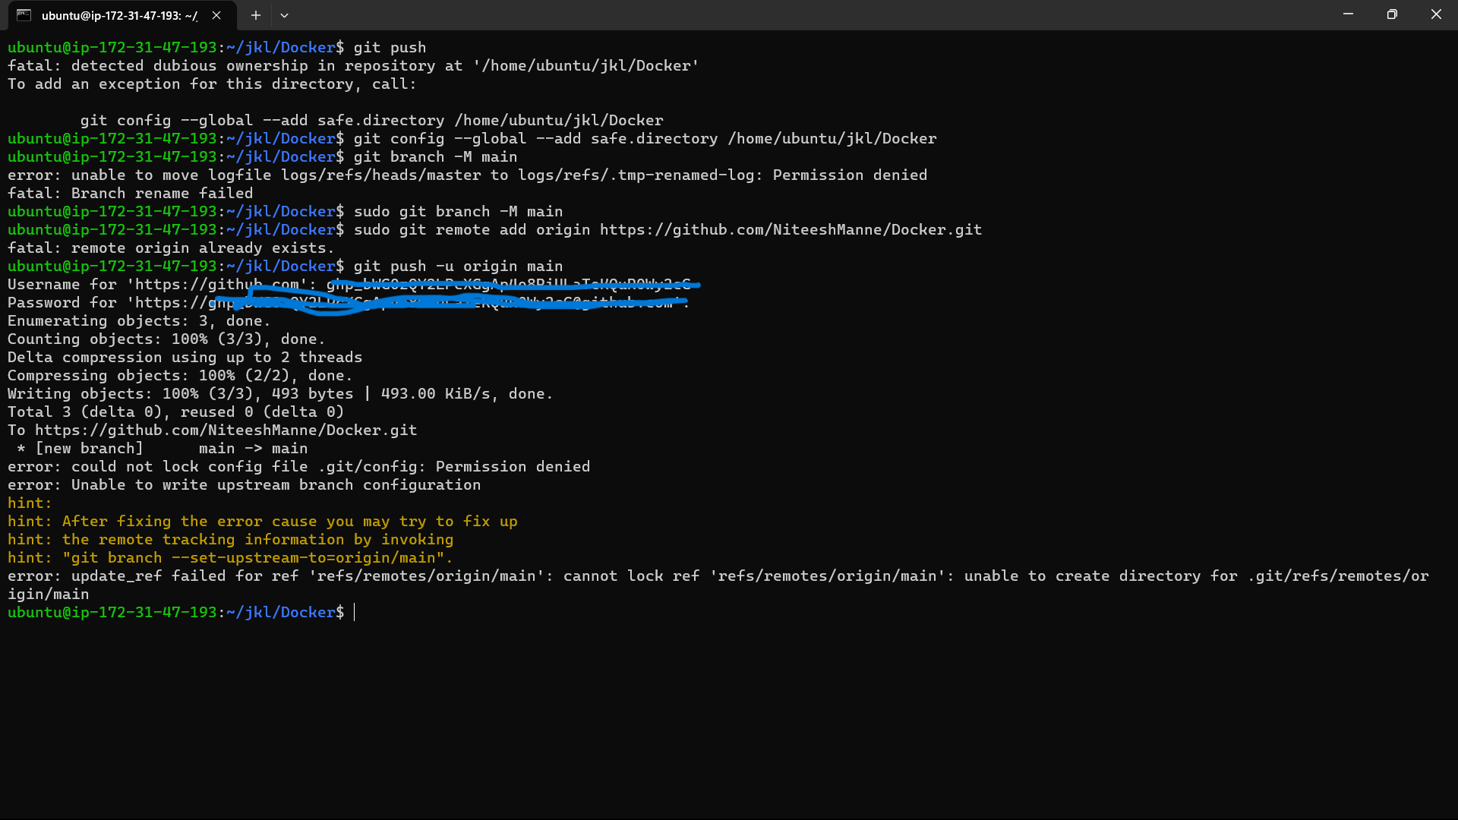

28)Now go to github repo and refresh the page you can see the pushed file.

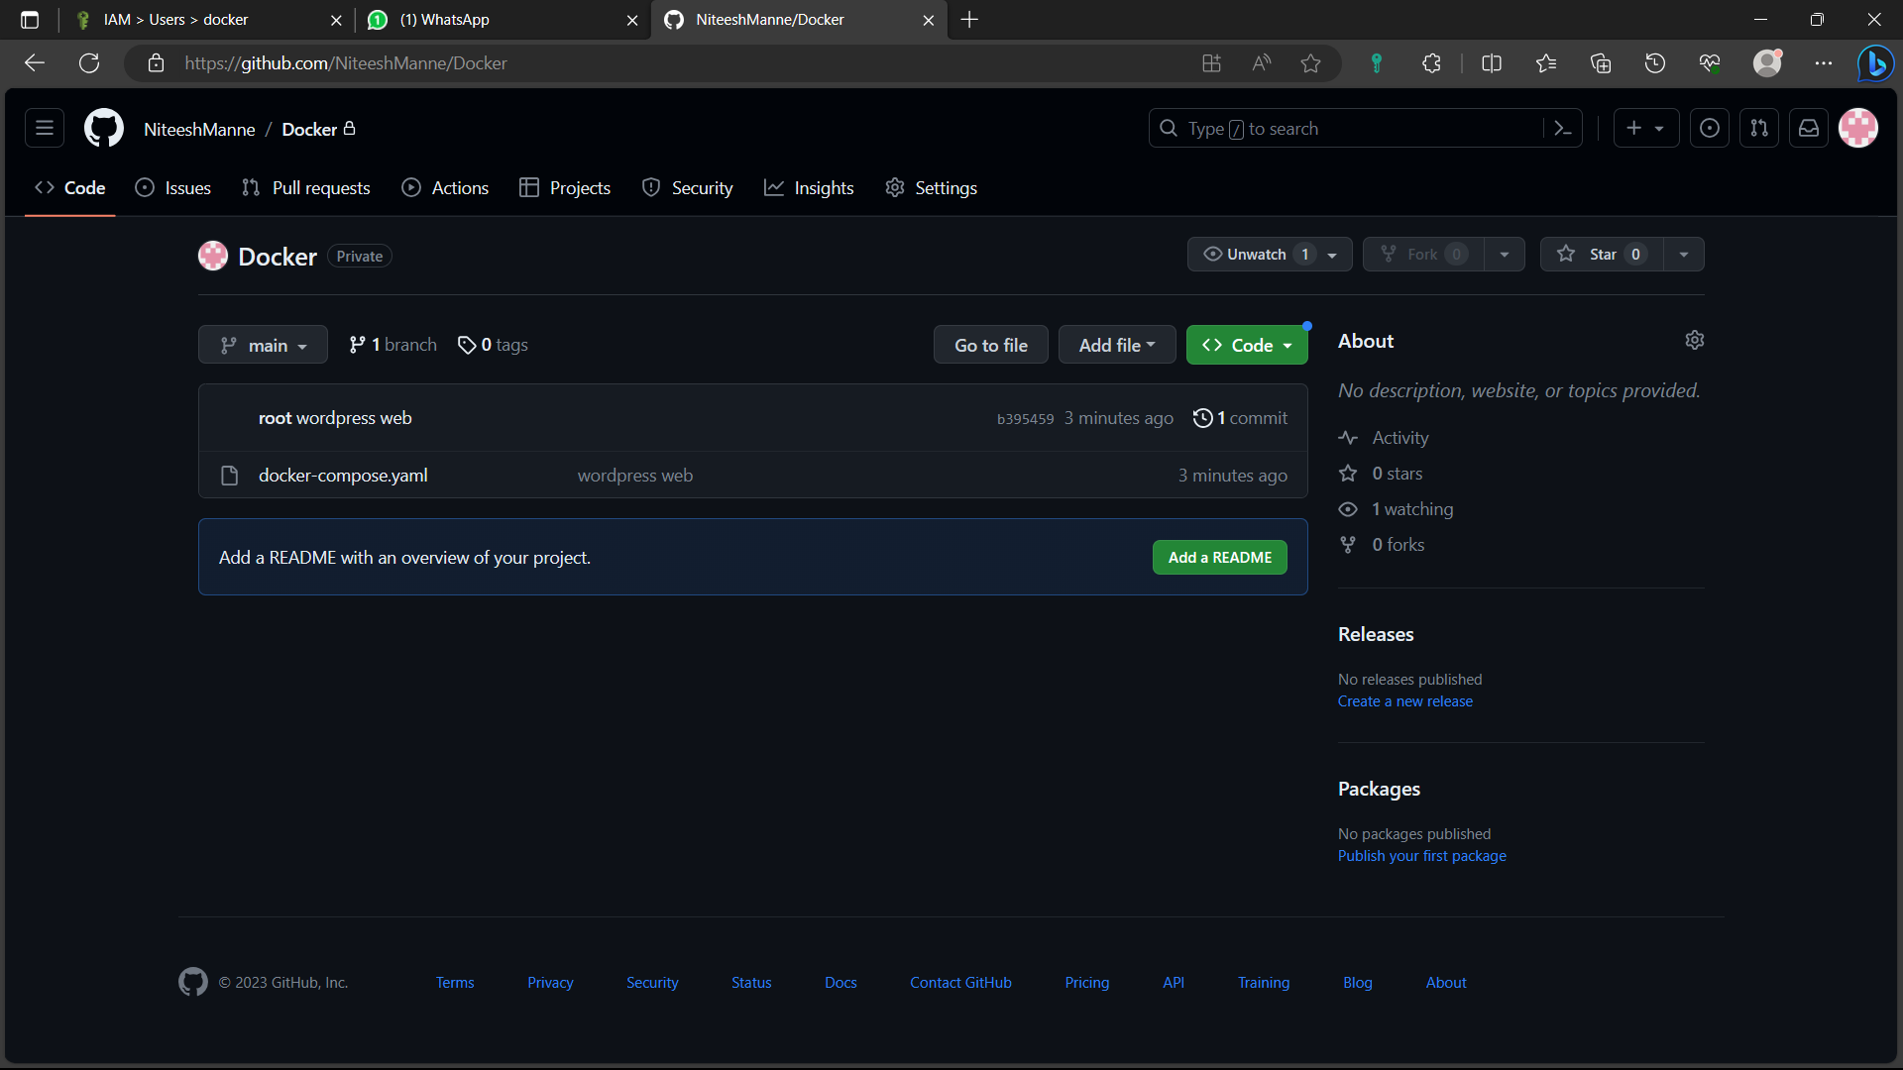

29)Create another instance in AWS by following the steps:(1-12).

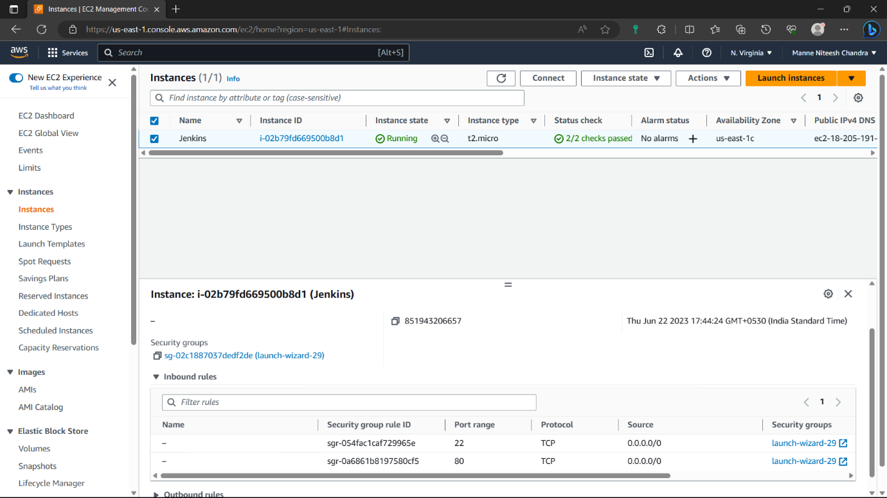

30)Access the instance in you’re local machine by following the steps : (13-18).

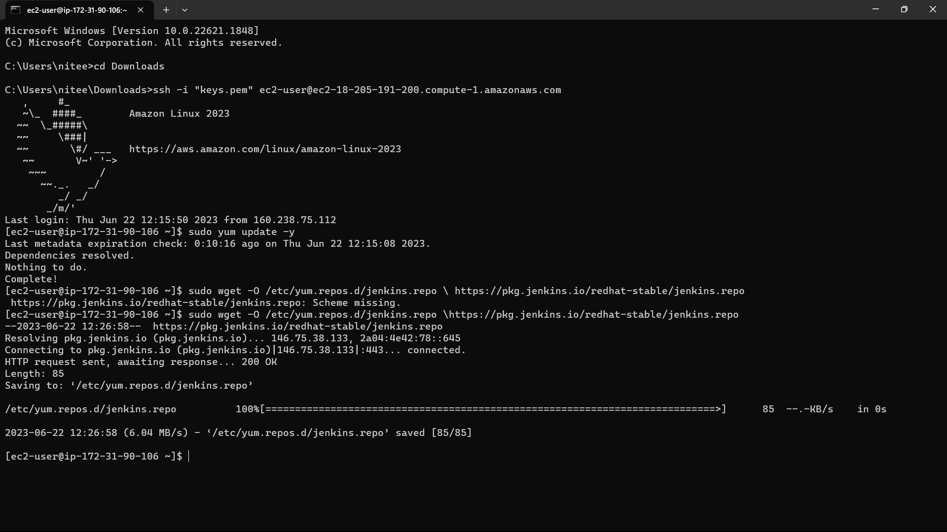

31) <https://www.jenkins.io/doc/tutorials/tutorial-for-installing-jenkins-on-AWS/>. Paste this link in the browse and copy the installation commands and paste in you’re instance.

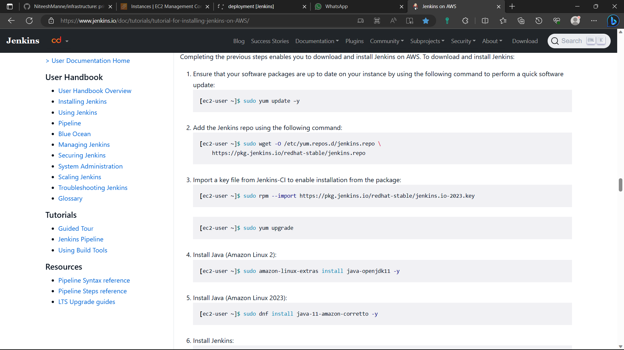

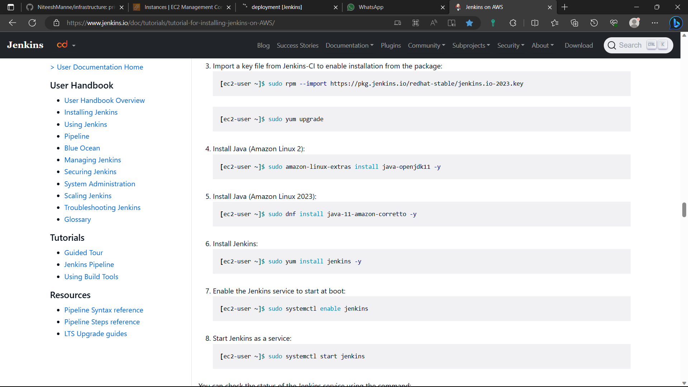

32)The Jenkins is installed in the instance.

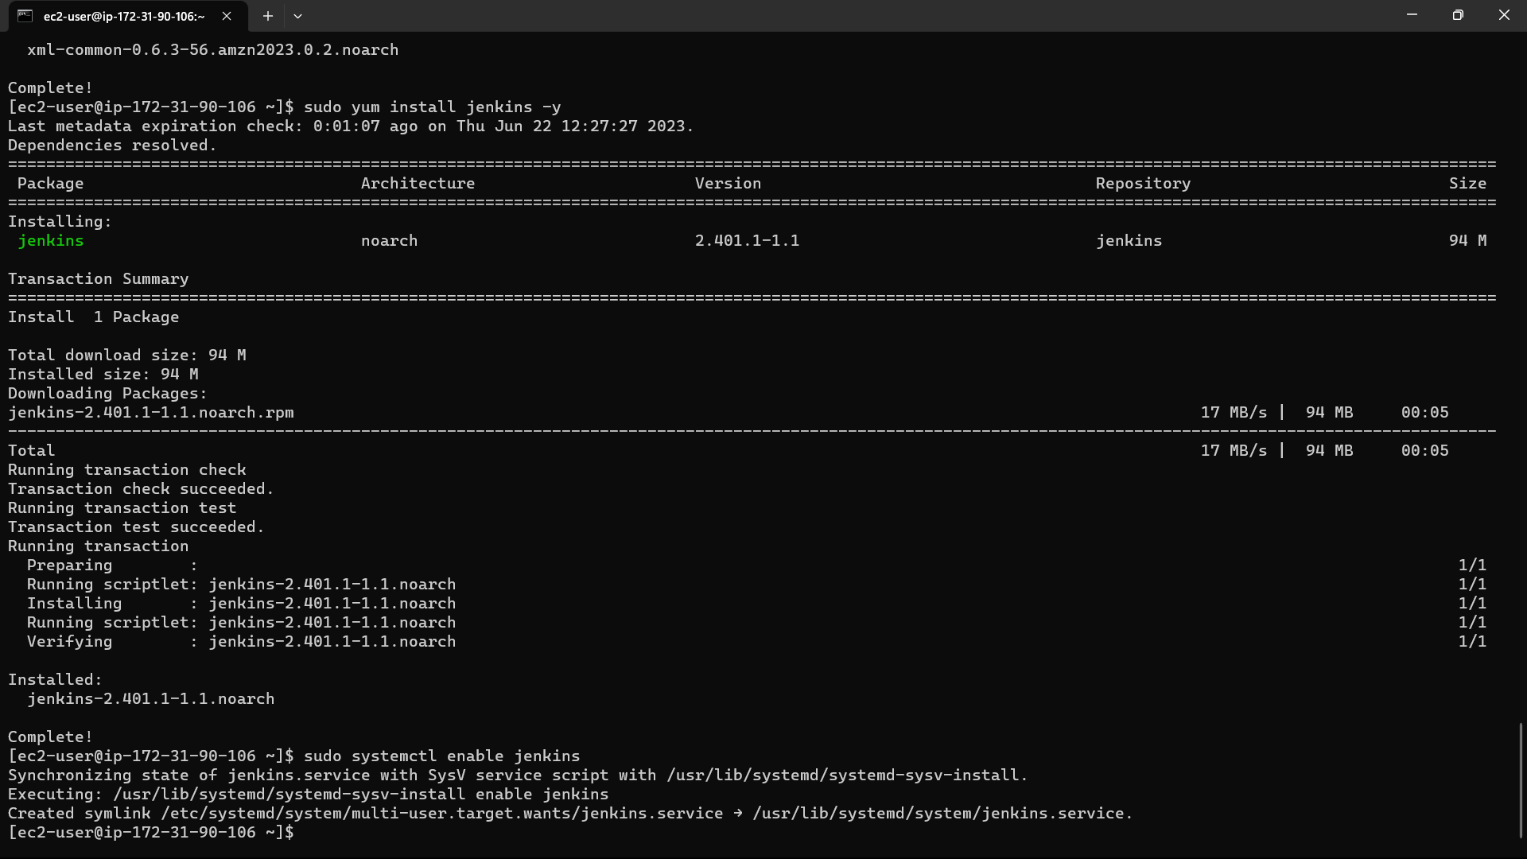

33)Now install git in the instance using the command “sudo yum install -y git”.

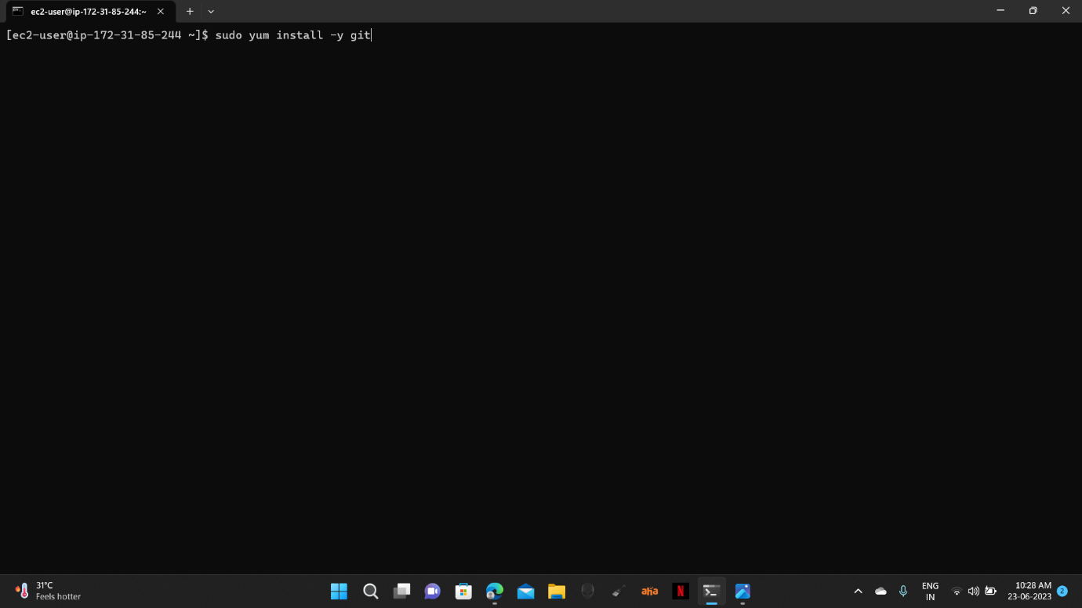

34)Now type the command “sudo visudo” for linux file.

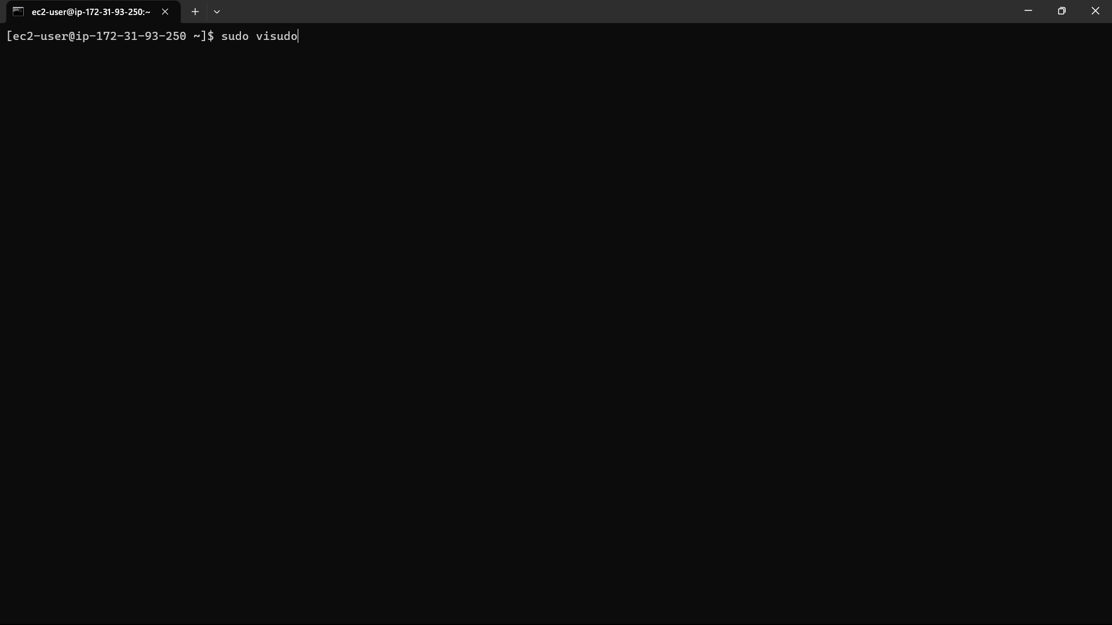

35)The file is opened. Go down and add an extra line below the root user i.e.,

“jenkins ALL=(ALL) NOPASSWD: ALL”. The ctrl+s, ctrl+x.

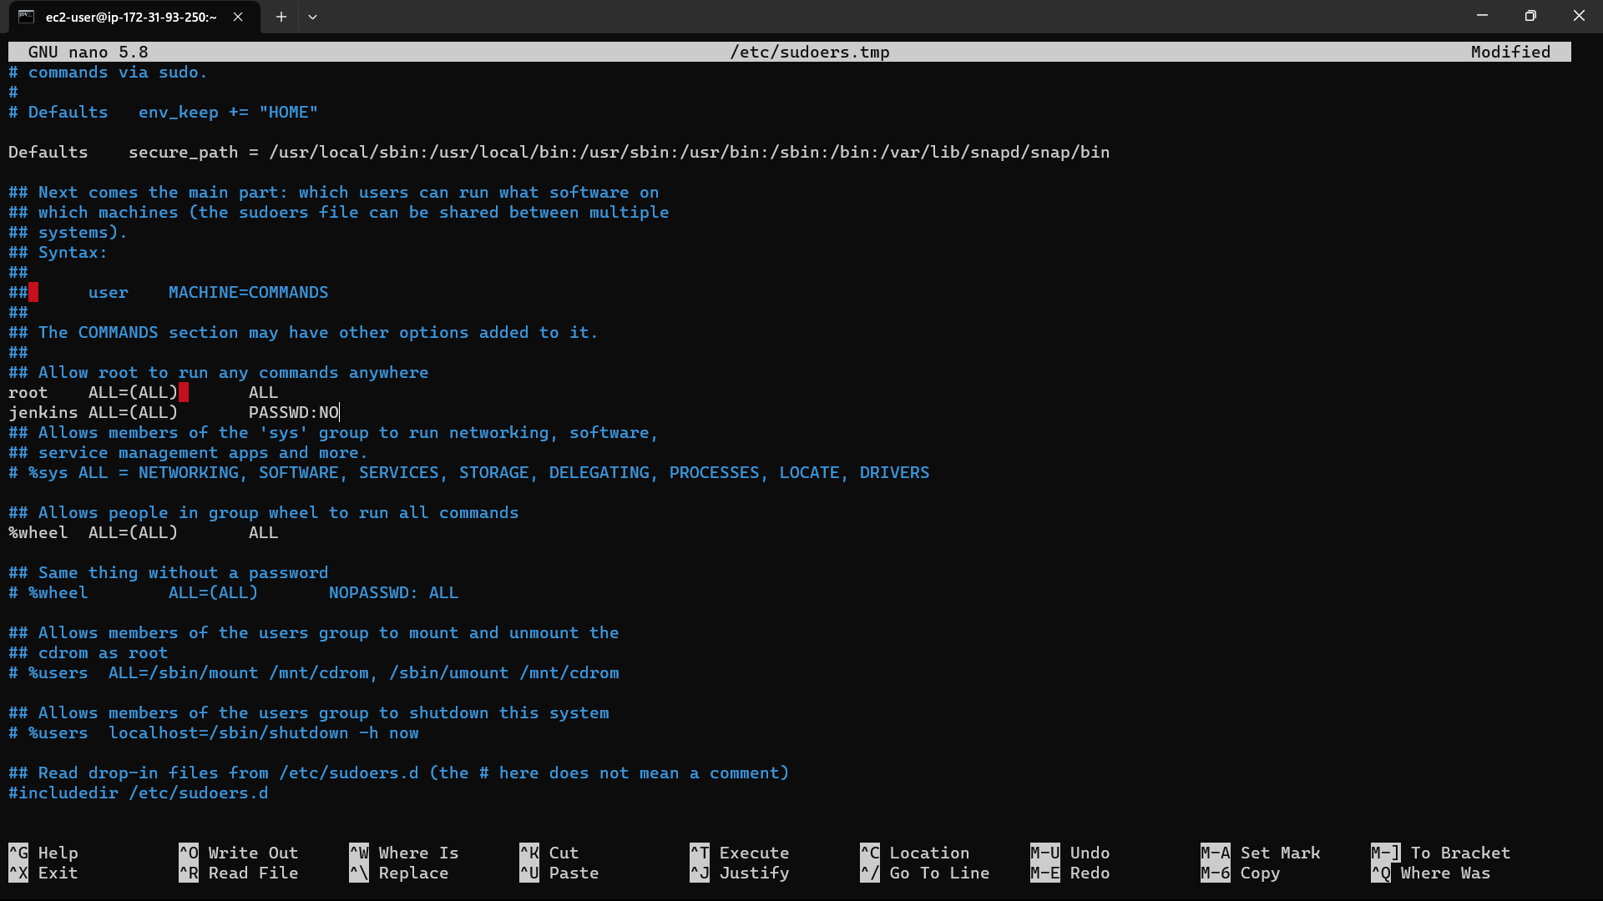

36)Go to the instances in console and select the instance you created.

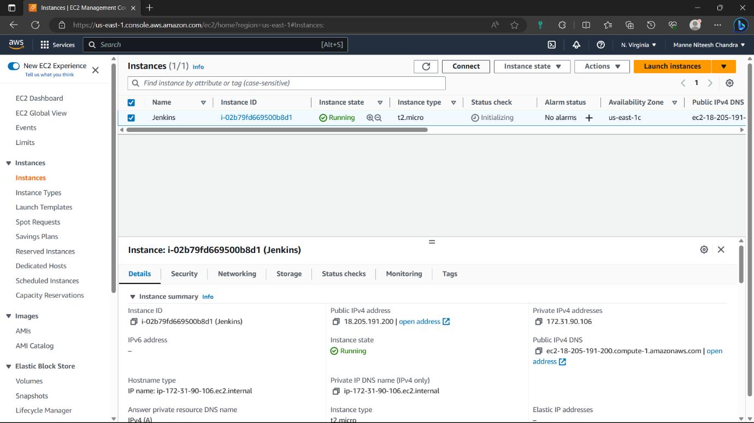

37)Navigate to security of the instance and click on the security group.



38)Click on “edit inbound rules” option.

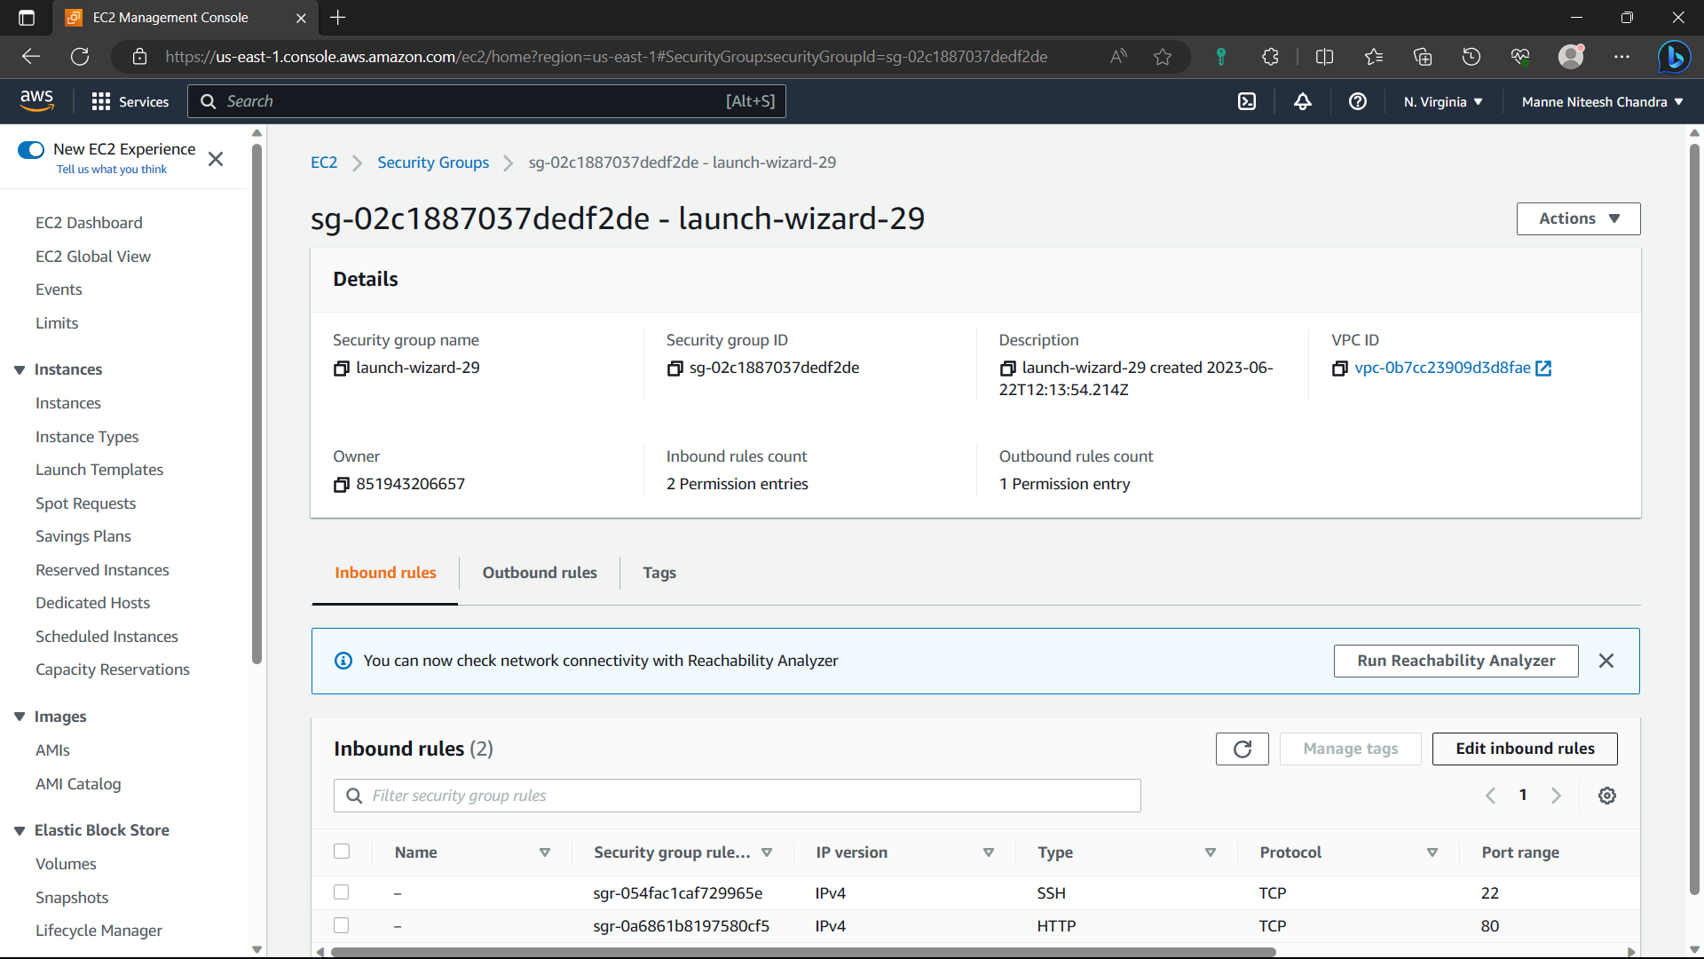

39)Click on “Add rule”.

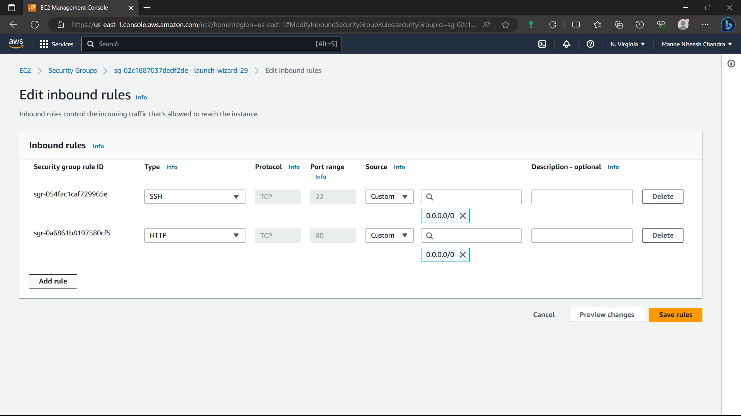

40)Type-Custom, port-8080, cidr-0.0.0.0/0 and click on “save rules” option.

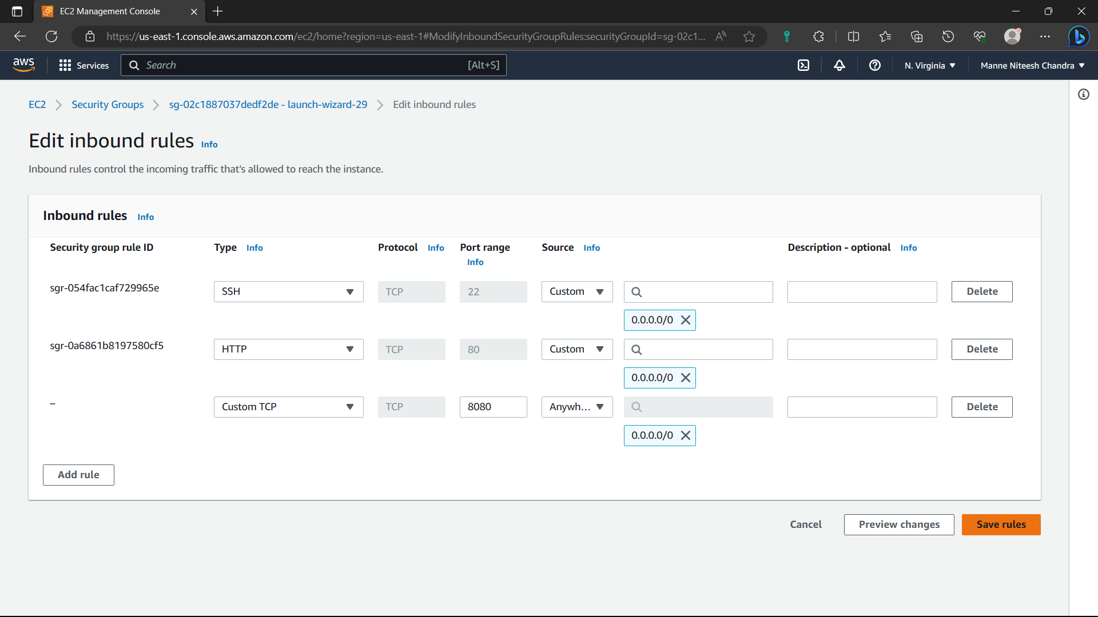

41)Now the rule is saved.

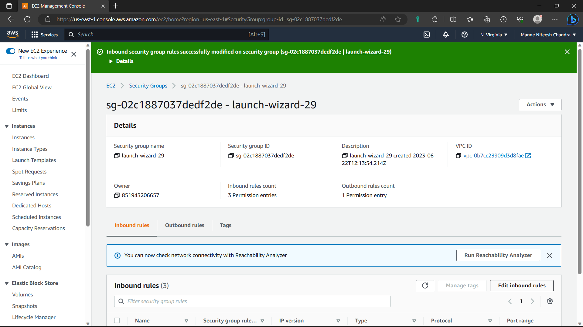

42)Go to “Instances” and select the instance you created and copy the ipv4address.

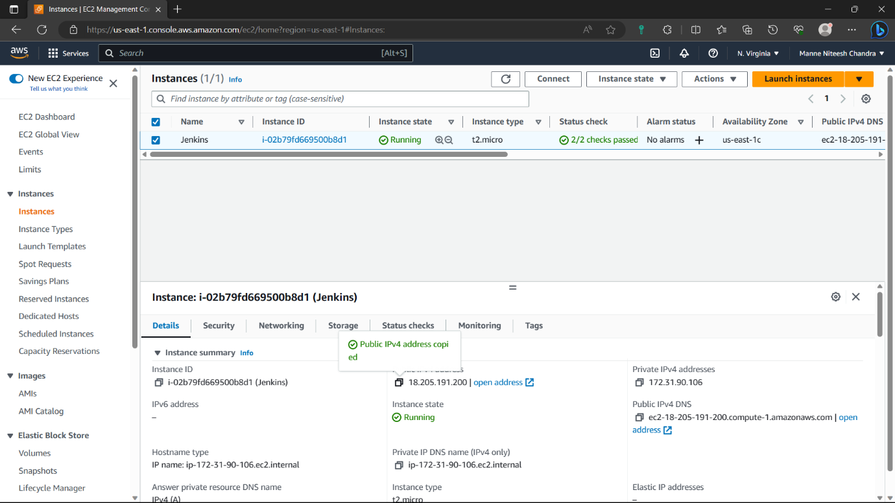

43)Before pasting it in browser add ”:8080” to the ipv4address to open Jenkins in the browser. Jenkins is opened in browser. Copy the pathi.e., in red colour.

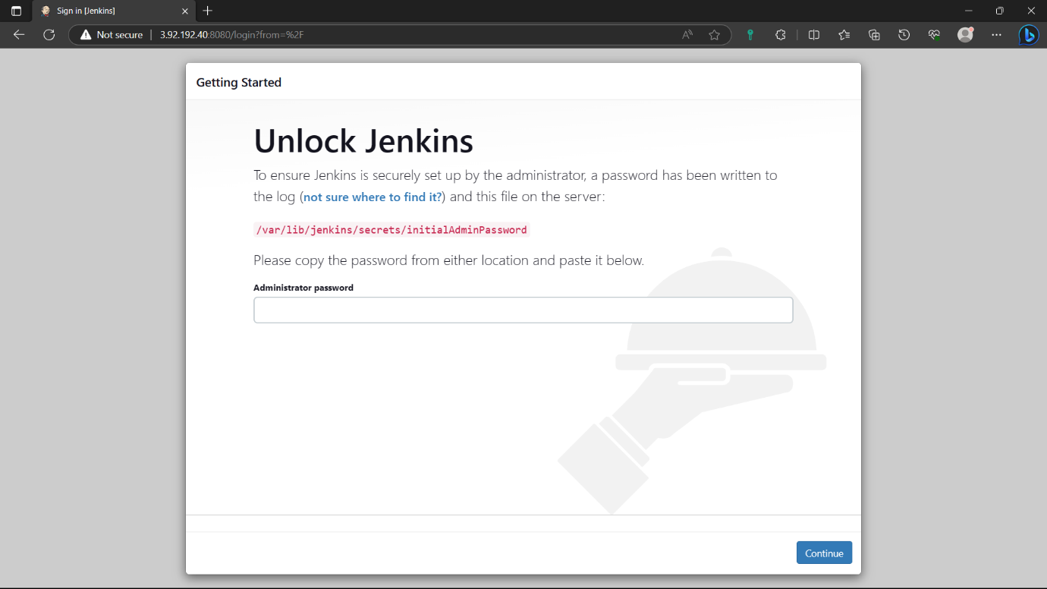

44)go to instance and type the command “sudo cat path”: for password to create Jenkins account.

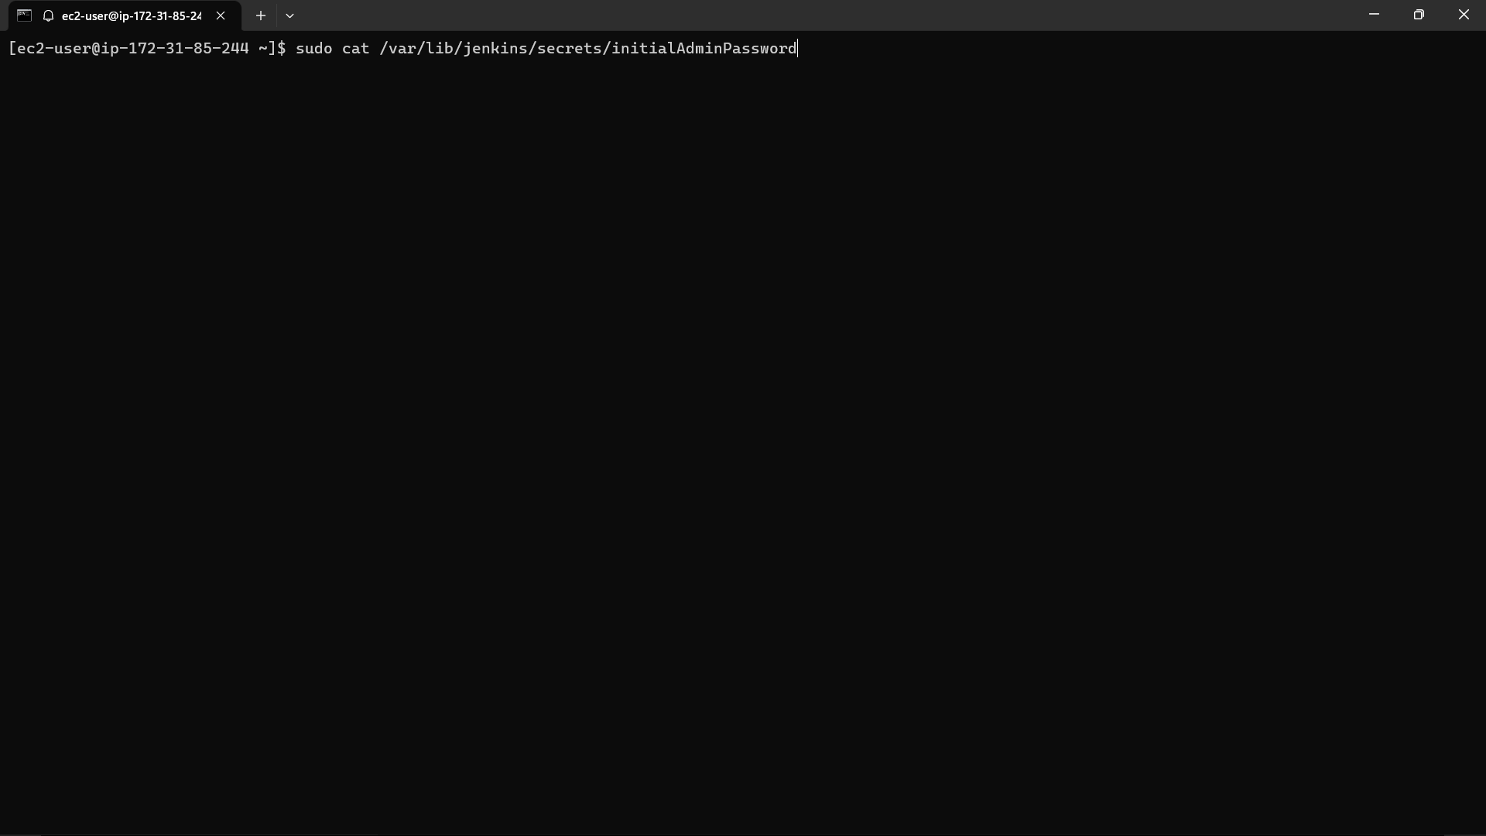

45)Copy the output and paste it in the Jenkins and click on continue.

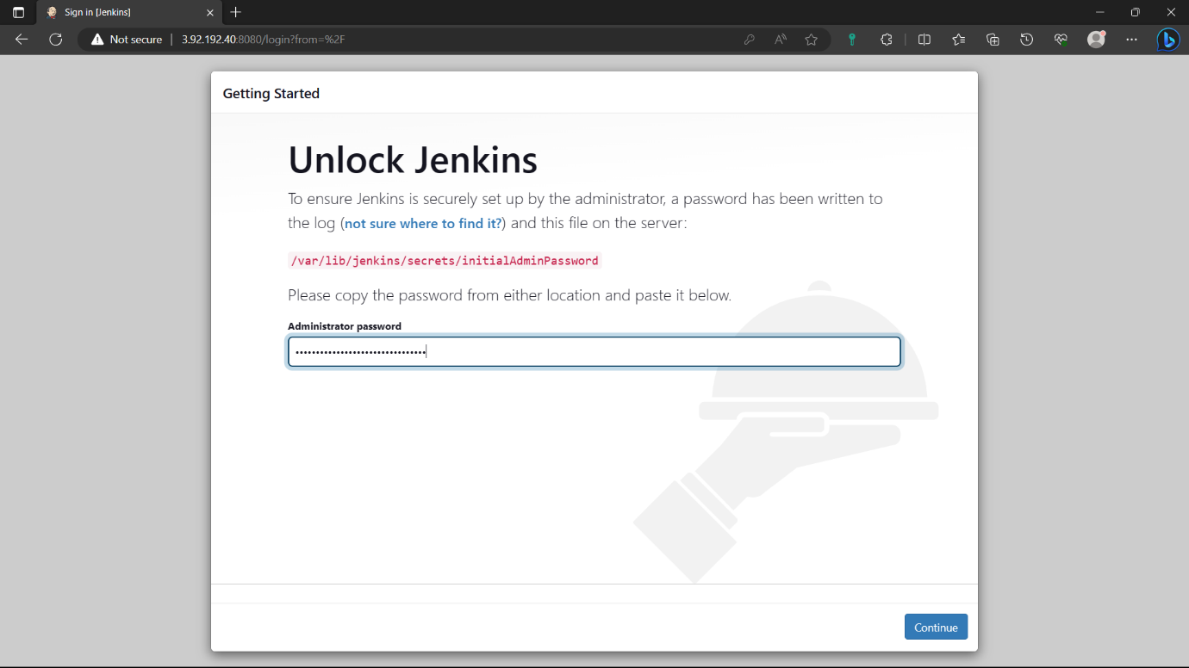

46)Select the “Install suggested plugins” option. And wait for some to install required plugins.

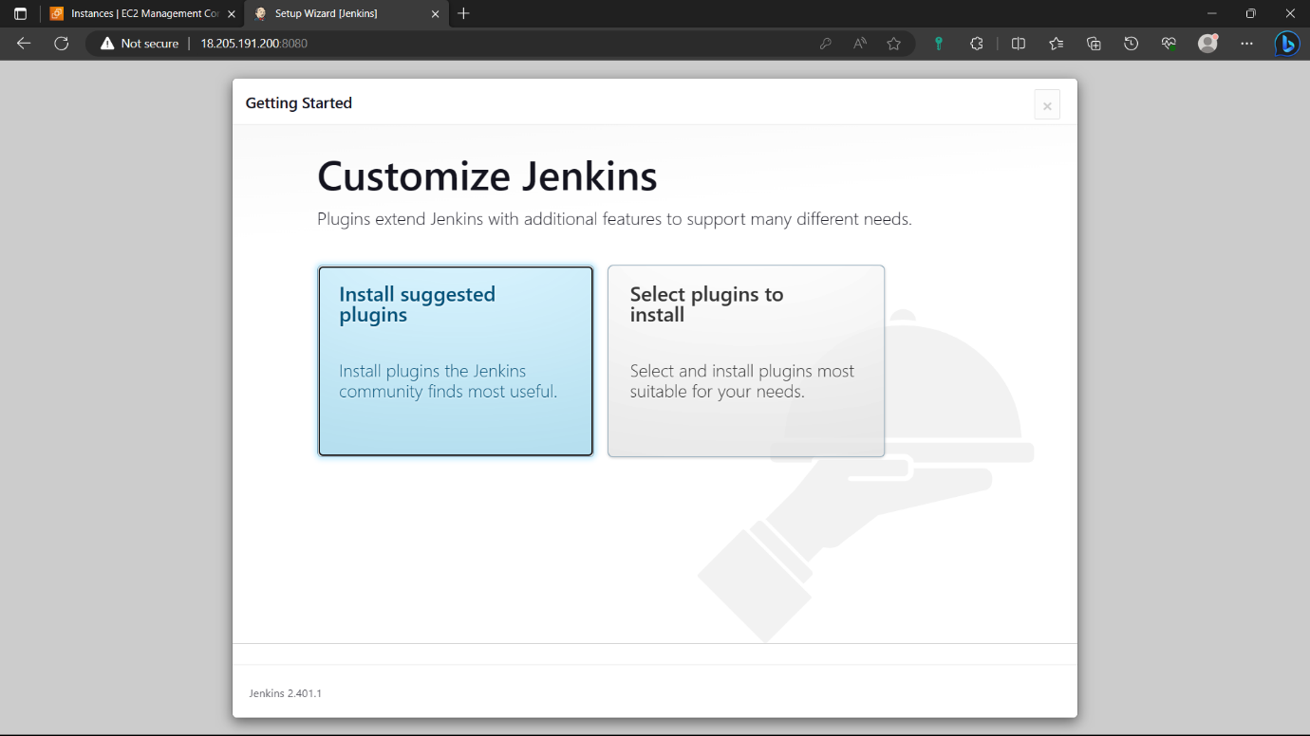

47)Give credentials to create an account click on “save and continue” and click on “continue” again.

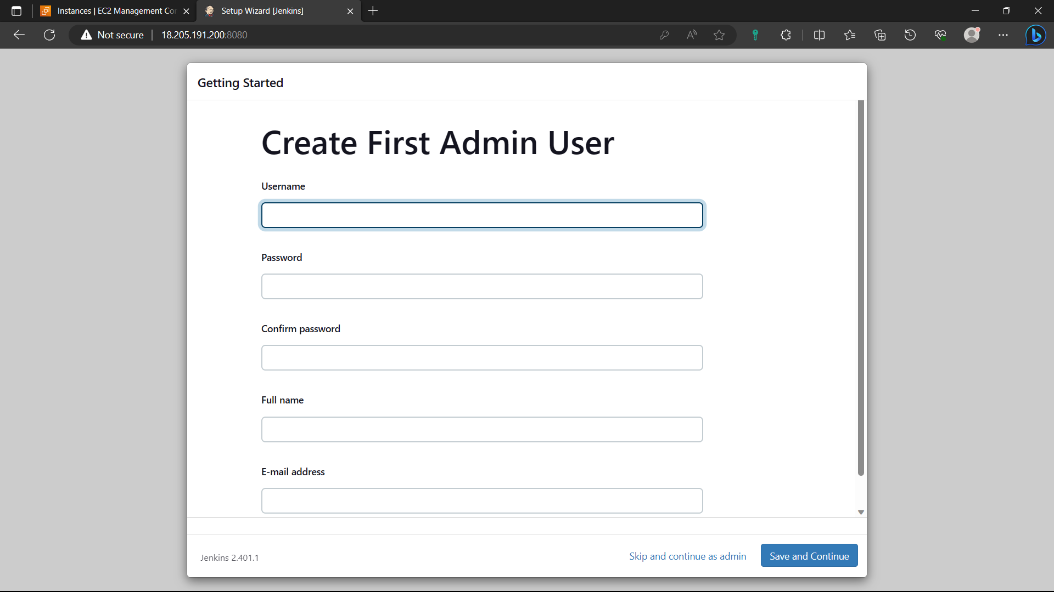

48)click on “start using Jenkins”.

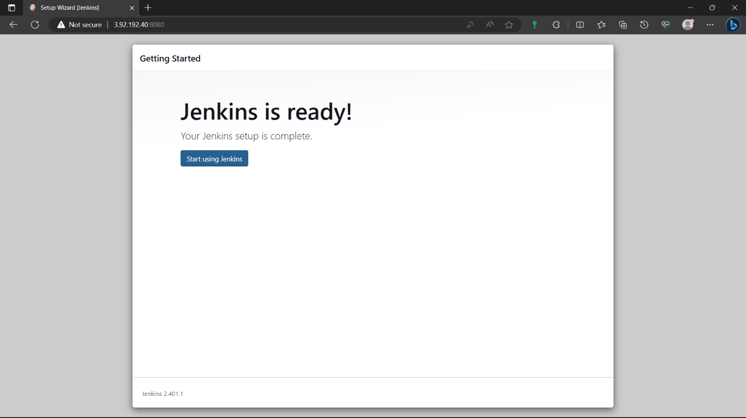

49)Jenkins is ready. Click on “create a job”.

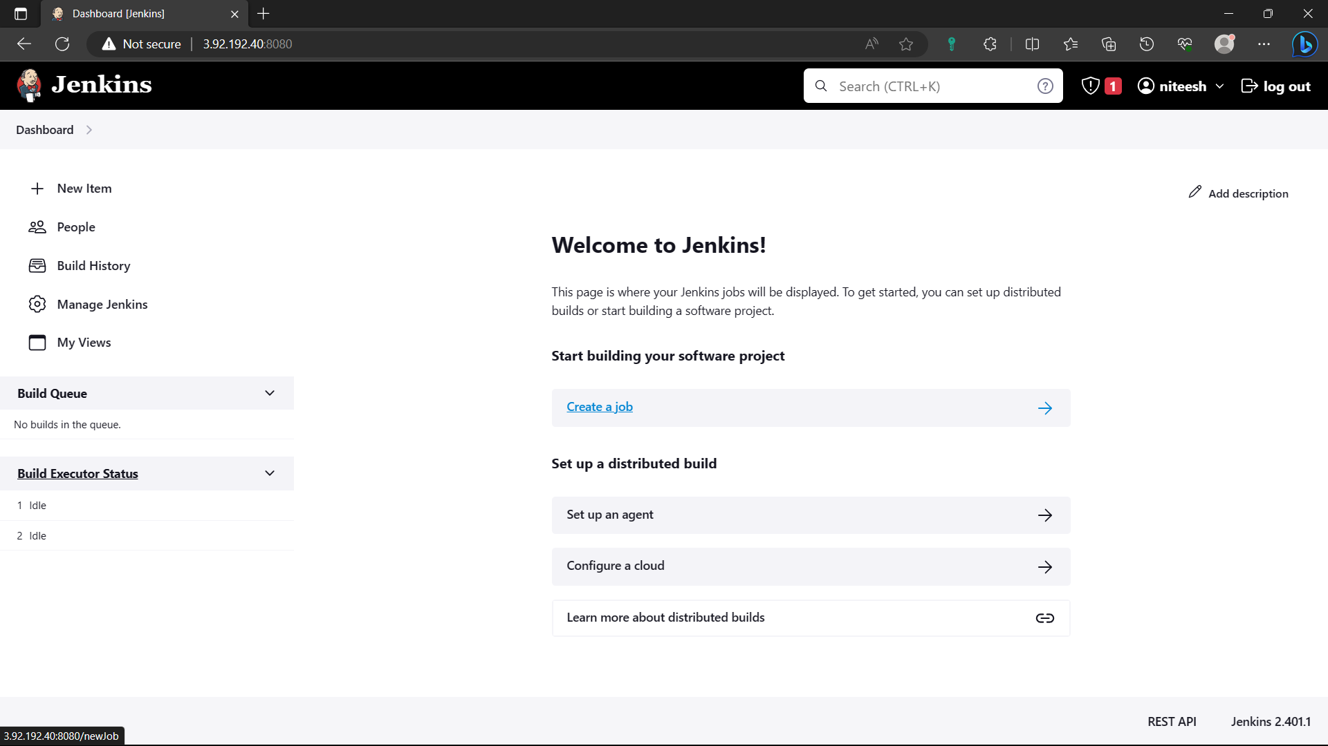

50)Give a name to the job, Select “Free style project”, click on “ok”.

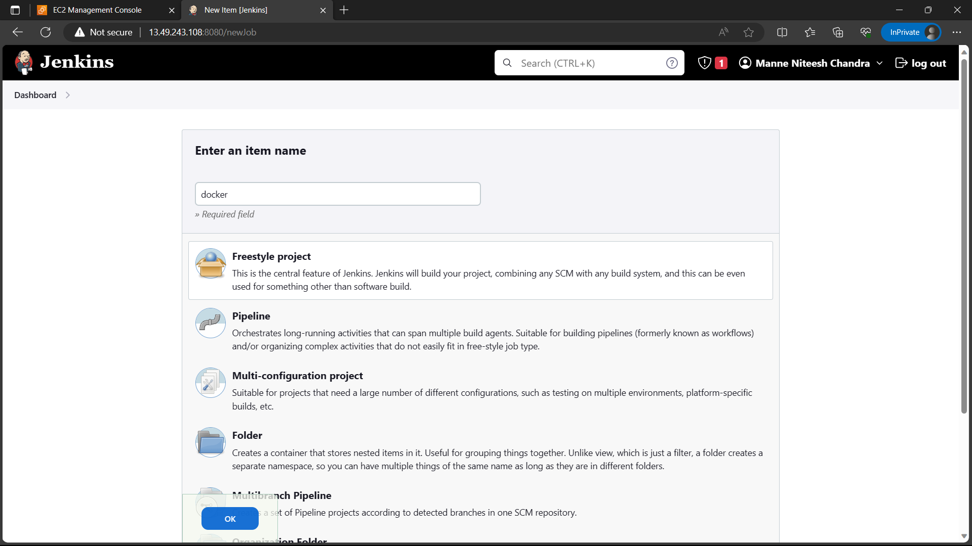

51)Go to github and copy the “HTTP” link from “code” of the repo where you pushed docker compose file.

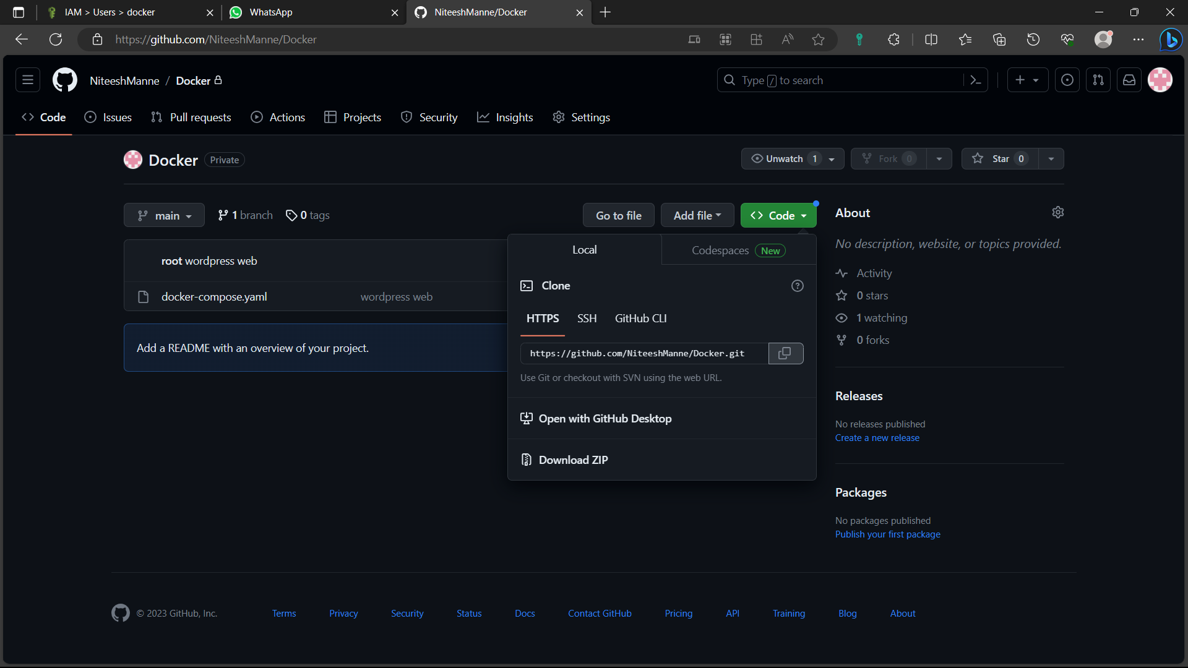

52)Paste it in the “Repository URL” and click on “Add”🡪”Jenkins”.

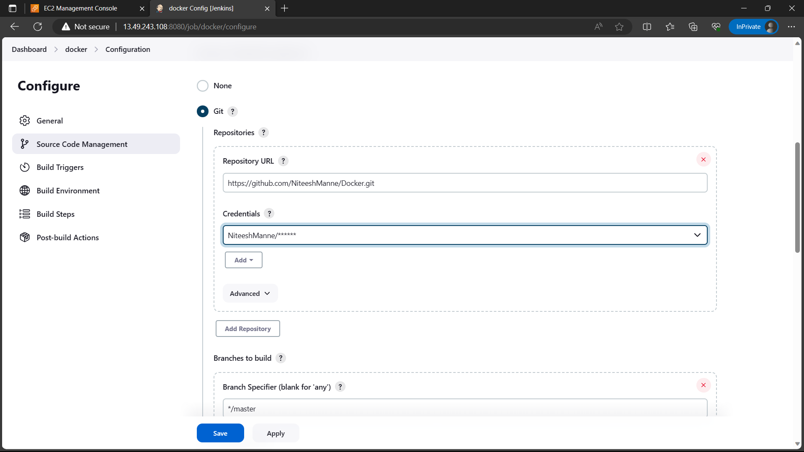

53)Give the github username and for password give personal token. And click on add. If you don’t have any follow the below step.

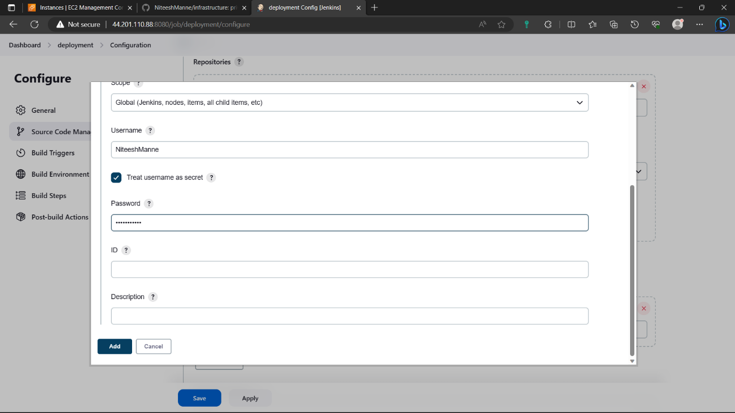

54)Click on profile🡪settings🡪developer settings🡪personal access token🡺create personal access token(classic)🡪give a name🡪enable repo🡪click on create🡪copy the token and paste it in secure file.

In credentials of Jenkins select your credentials.

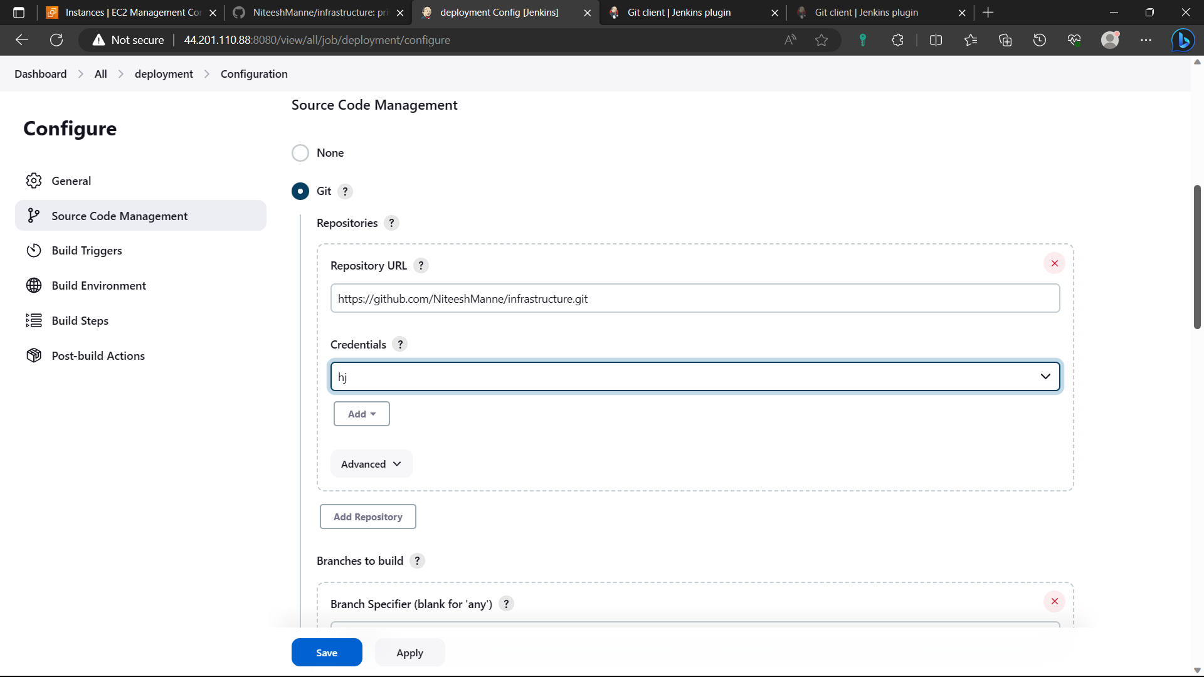

55)Change branch name to “main” if your branch name is “main”.

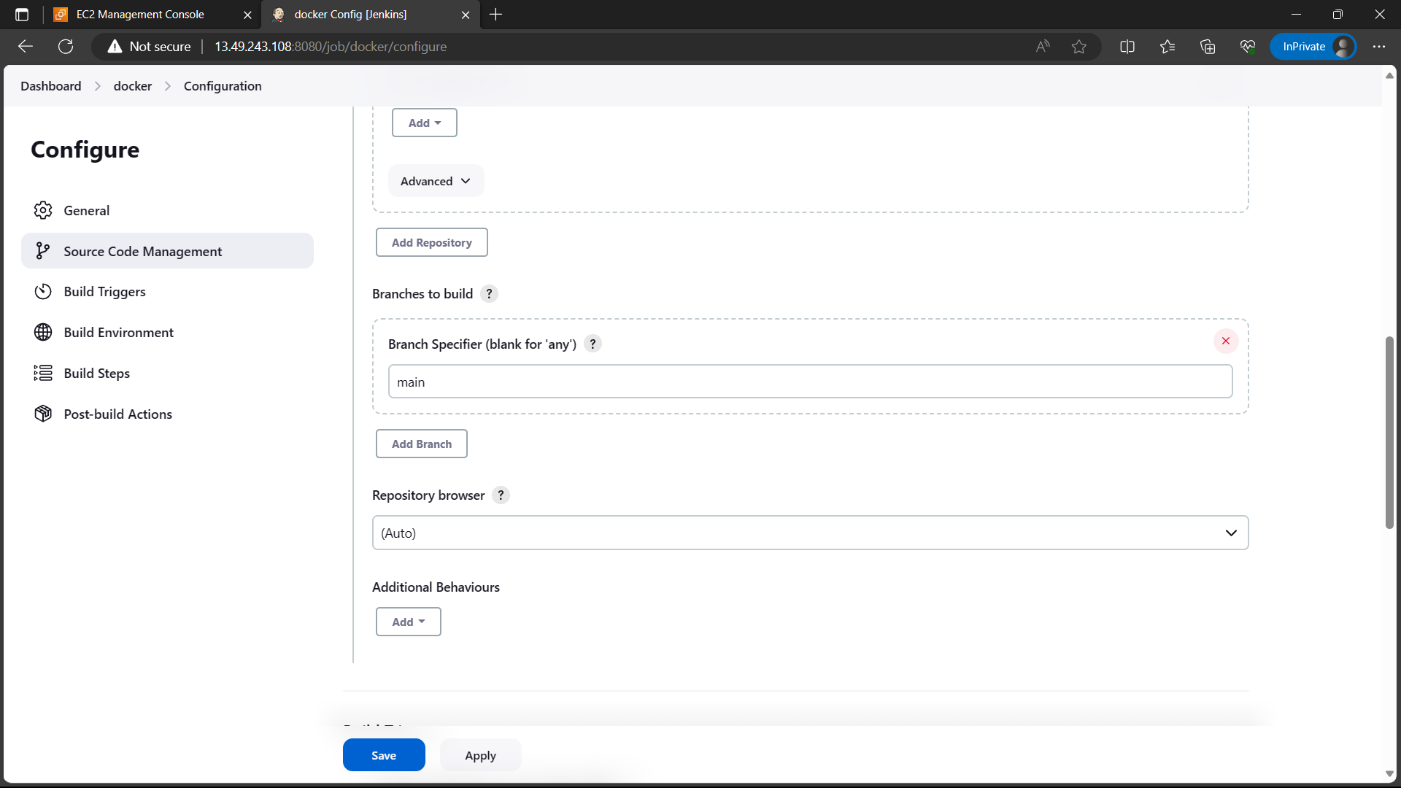

56)Now go to ”Build steps” select “execute shell” and type the below commands. Click on “save” option.

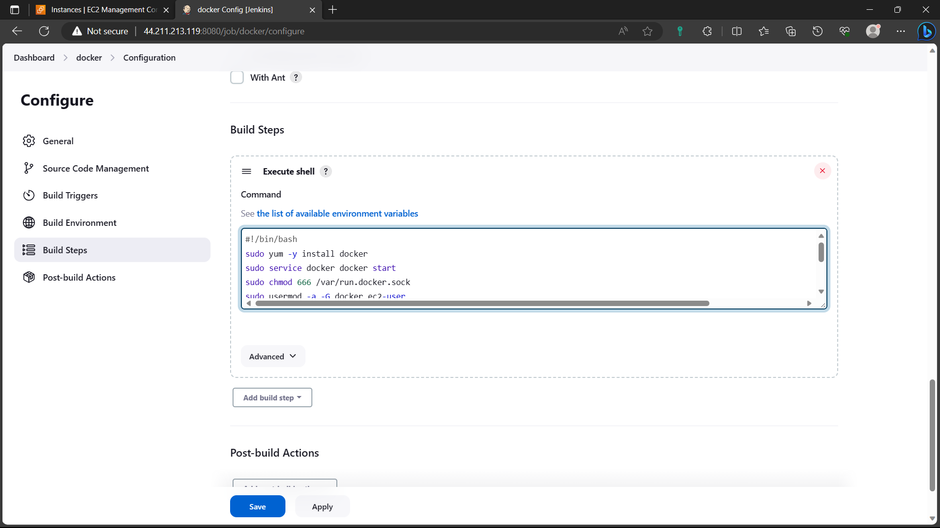

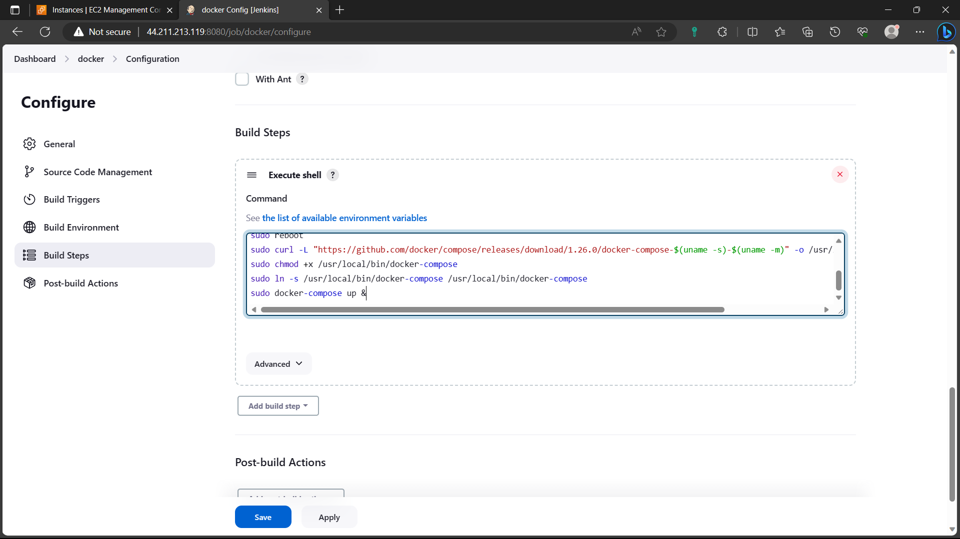

57)Click on “Build now” option now job is currently executing you can see it below search bar in navigation panel.

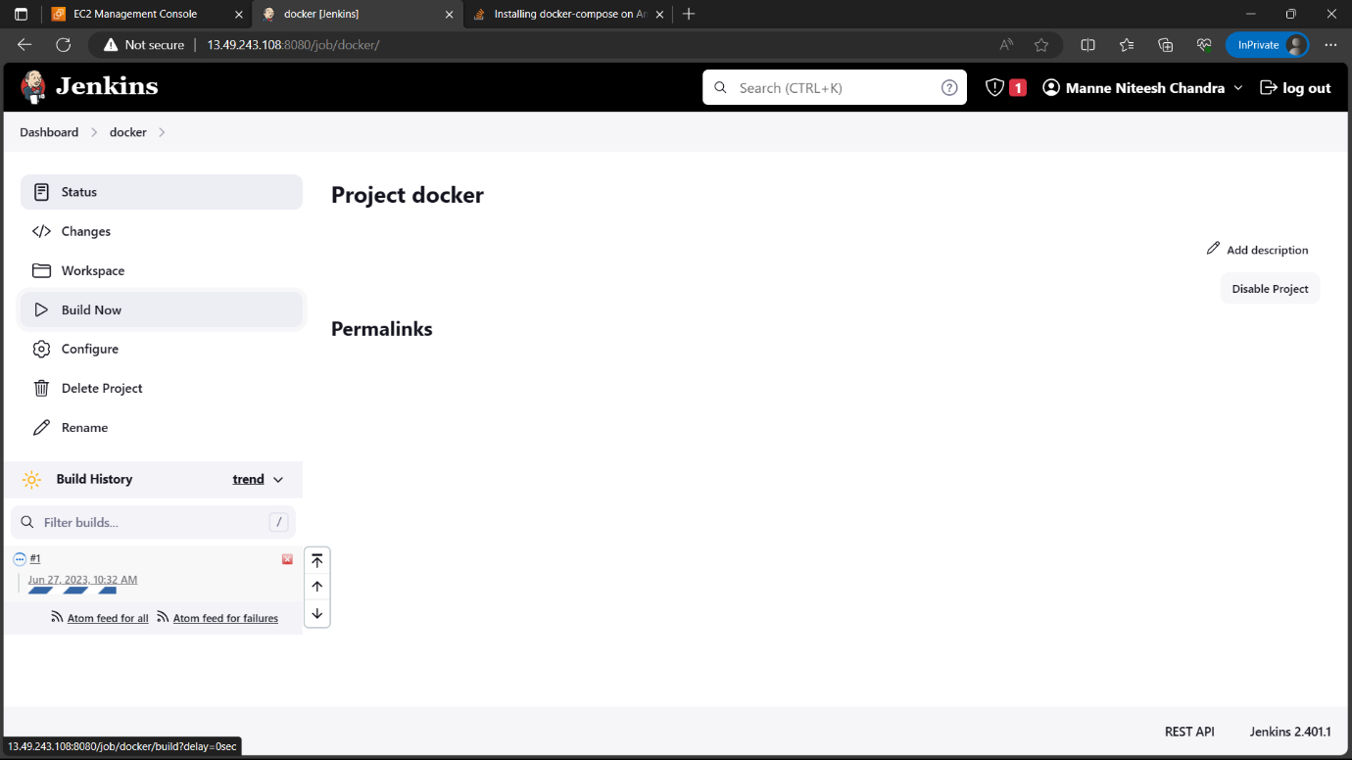

58)Select the “#1” and go to “console output”.

